REPUBLIC OF RWANDA


MINISTRY OF EDUCATION

ANNUAL REPORT

JULY 2013 – JUNE 2014

SEPTEMBER 2014

Table of Contents
LIST OF TABLES 4
LIST OF GRAPHS 5
LIST OF PHOTOS 7
ACRONYMS AND ABBREVIATIONS 8
FOREWORD 9
EXECUTIVE SUMMARY 11
GENERAL INTRODUCTION 16
CHAPTER 1: PROGRESS AGAINST ESSP OUTCOME “IMPROVED ACCESS TO SCHOOL READINESS PROGRAMMES BY 2017/18, ACCOMPANIED BY EXPANDED ACCESS TO THREE-YEARS OF EARLY LEARNING FOR FOUR-TO-SIX-YEAR OLDS” 20
1.1. CURRENT SITUATION IN PRE-PRIMARY EDUCATION 20
1.2. PROGRESS AGAINST ESSP 2013/14 – 2017/18 MAJOR TARGETS 21
1.3. OTHER ACHIEVEMENTS 22
CHAPTER 2: PROGRESS AGAINST ESSP OUTCOME “INCREASED EQUITABLE ACCESS TO 9 YEARS OF BASIC EDUCATION FOR ALL CHILDREN AND EXPANDING ACCESS TO 12 YEARS OF BASIC EDUCATION” 23
2.1. CURRENT SITUATION IN PRIMARY AND SECONDARY EDUCATION 23
2.1.1. Primary Education 23
2.1.2. Secondary Education 24
2.2. PROGRESS AGAINST ESSP 2013/14–2017/18 MAJOR TARGETS 25
2.2.1. Primary Education 25
2.2.2. Secondary Education 28
2.3. OTHER ACHIEVEMENTS 34
2.4. CHALLENGES 37
2.5. RECOMMENDATIONS 37
CHAPTER 3: PROGRESS ON IMPROVED QUALITY AND LEARNING OUTCOMES ACROSS PRIMARY AND SECONDARY EDUCATION 39
3.1. INRODUCTION 39
3.2. PROGRESS AGAINST ESSP MAJOR TARGETS 39
3.3. OTHER ACHIEVEMENTS 45
3.3.1. Primary level 45
3.3.2. Lower secondary level 45
3.3.3. Upper secondary 46
3.3.4. Examinations statistics and performance 46
CHAPTER 4: CHANGES IN INCREASED EQUITABLE ACCESS TO EDUCATION FOR STUDENTS WITH SPECIAL EDUCATIONAL NEEDS WITHIN MAINSTREAM AND SPECIAL SCHOOLS 48
4.1. INTRODUCTION 48
4.2. PROGRESS AGAINST ESSP MAJOR TARGETS 48
CHAPTER 5: EFFORTS AND RESULTS IN PROVIDING QUALIFIED, SUITABLY-SKILLED AND MOTIVATED TEACHERS AND TRAINERS TO MEET DEMANDS OF EXPANDING EDUCATION ACCESS. 51
5.1. INTRODUCTION 51
5.2. PROGRESS AGAINST ESSP TARGETS 52
5.3. OTHER ACHIEVEMENTS 53
CHAPTER 6: PROGRESS ON THE ESSP OUTCOME “INCREASED EQUITABLE ACCESS TO RELEVANT, HIGH-QUALITY, DEMAND-DRIVEN TVET PROGRAMMES” 54
6.1. INTRODUCTION 54
6.2. PROGRESS AGAINST ESSP MAJOR TARGETS 54
6.3. OTHER ACHIEVEMENTS 54
CHAPTER 7: INITIATIVES AND IMPROVEMENTS IN THE EQUITABLE ACCESS TO AFFORDABLE, RELEVANT, ACADEMICALLY EXCELLENT HIGHER EDUCATION THAT ALSO DELIVERS QUALITY RESEARCH OUTPUTS 61
7.1. INTRODUCTION 61
7.2. ESTABLISHMENT OF THE UNIVERSITY OF RWANDA 61
7.3. ACCESS TO HIGHER EDUCATION 62
7.4. QUALITY EDUCATION 64
7.5. OTHER ACHIEVEMENTS 65
7.6. CHALLENGES 67
7.7. KEY RECOMMENDATIONS 67
CHAPTER 8: PROGRESS AGAINST ESSP OUTCOME “STRENGTHENED PERFORMANCE IN SCIENCE, TECHNOLOGY AND INNOVATION AT ALL LEVELS OF EDUCATION, AND APPLICATION OF SCIENCE, TECHNOLOGY AND INNOVATION IN RELEVANT SECTORS OF THE ECONOMY” 69
8.1. INTRODUCTION 69
8.2. PROGRESS AGAINST ESSP MAJOR TARGETS 69
8.2.1. Primary education 70
8.2.2. Secondary education 72
8.2.3. Higher education 75
8.3. OTHER MAJOR ACHIEVEMENTS 75
8.3.1. ICT in education 75
8.3.2. Achievements in strengthening the application of STI in relevant sectors of the economy 78
CHAPTER 9: ADULT BASIC EDUCATION, ADULT LITERACY AND NUMERACY ACHIEVEMENTS 83
CHAPTER 10: INITIATIVES FOCUSED ON IMPROVING ADMINISTRATIVE AND MANAGEMENT SUPPORT SERVICES, INCLUDING THE MANAGEMENT OF POLICY, INFORMATION, FINANCES, AND HUMAN RESOURCES ACROSS THE EDUCATION SECTOR. 86
CHAPTER 11: BUDGET AND FINANCE IN EDUCATION SECTOR IN FISCAL YEAR 2013/2014 88
11.1. GOVERNMENT OF RWANDA BUDGET AND EXPENDITURE 2013/2014 88
11.2. Overseas Development Aid (ODA) disbursement and effectiveness 92
11.3. UNIT COST ANALYSIS 93
11.4. PROGRESS AGAINST ESSP FINANCIAL INDICATOR TARGETS 95
11.5. CHALLENGES 95
Annex I: ANNUAL ACHIEVEMENTS BASED ON DETAILED 2013/14 ACTION PLAN 97
ANNEX II: SECTOR PRIORITY AND POLICY ACTIONS MATRIX 2013/14 131
ANNEX III: ESSP AND EDPRS II KEY INDICATORS AND THEIR TARGETS 142

LIST OF TABLES
Table 1: Number of pupils in pre-primary in 2012 and 2013 20
Table 2: Number of pre-primary schools in 2012 and 2013 21
Table 3: Number of pupils in primary education 2012 and 2013 23
Table 4: Number of schools in primary education in 2012 and 2013 23
Table 5: Number of students in secondary schools in 2012 and 2013 24
Table 6: Number of secondary schools in 2012 and 2013 24
Table 7: Comparison between pupils/classroom ratios and number of pupils per class with ESSP target 33
Table 8: Number of desks for students, chairs and tables provided per province 35
Table 10: Upper secondary students' performance for 2013 47
Table 11: Primary and secondary schools/qualified teacher ratio 52
Table 12: Main achievements of TVET programmes 56
Table 13: Trend in TVET schools from 2010-2013 57
Table 14: Major activities and achievements in quality assurance in higher education 64
Table 15: MINEDUC, agencies, and district budget allocation and execution by economic category for fiscal year 2013/14 87
Table 16: Budget allocation and execution at the central vs. decentralised level for fiscal year 2013/14 88
Table 17: Central MINEDUC budget allocation and execution by programme for fiscal year 2013/14 88
Table 18: Education sector budget allocation and execution by level for fiscal year 2013/14 90
Table 19: ODA funds committed and disbursed in fiscal year 2013/2014, by country and project (millions Rwandan Francs) 92
Table 20: Total recurrent expenditure cost per student, by level (2012-2014) 96
Table 21: Total capital expenditure cost per student, by level (2012-2014) 97
Table 22: Education sector actual and predicted required budget by level (Rwf) 2013/2014 98

LIST OF GRAPHS
Graph 1: Gross Enrolment Rate in pre-primary education in 2012 and 2013 21
Graph 2: Net Enrolment Rate in pre-primary education 22
Graph 3: Primary Gross Enrolment Rate in 2012 and 2013 25
Graph 4: Primary completion rate in 2012 and 2013 26
Graph 5: Primary Net Enrolment Rate in 2012 and 2013 26
Graph 6: % of primary schools with access to electricity 27
Graph 7: percentage of primary schools with access to alternative energy sources 28
Graph 8: percentage of primary schools with access to clean water in 2012 and 2013 28
Graph 9: Gross Enrolment Rate in lower secondary in 2012 and 2013 29
Graph 10: Net Enrolment Rate in lower secondary in 2012 and 2013 30
Graph 11: Transition rate from lower to general upper secondary for 2012 and 2013 30
Graph 12: Gross Enrolment Rate in upper secondary schools 31
Graph 13: Net Enrolment Rate in upper secondary education 31
Graph 14: % of secondary schools with access to electricity 32
Graph 15: % of secondary schools with access to alternative energy sources 32
Graph 16: Secondary schools access to clean water 33
Graph 18: Primary school repetition rate, actual and ESSP targets 39
Graph 19: Primary school dropout rate, actual and ESSP targets 40
Graph 20: Lower secondary repetition rate, actual and ESSP targets 40
Graph 21: Lower secondary dropout rate, actual and ESSP targets 41
Graph 22: Upper secondary repetition rate, actual and ESSP targets 42
Graph 23: Upper secondary dropout rate, actual and ESSP targets 42
Graph 24: Library situation in primary schools 43
Graph 25: Library situation in secondary schools 44
Graph 26: Percentage of students passing national S3 exams 44
Graph 27: Percentage of students passing national S6 exams 45
Graph 28: Trend in children with disability in primary and secondary schools 49
Graph 29: Number of teachers trained in Special Needs Education 50
Graph 30: Qualified staff situation in primary and secondary schools 51
Graph 31: Qualified teacher numbers in primary and secondary schools 52
Graph 32: TVET enrolment, actual and targets 54
Graph 33: % of TVET schools per providers 58
Graph 34: UR colleges and student numbers at opening 62
Graph 35: Trend in students' enrolment in public and private tertiary institutions (2009- 63
Graph 36: Tertiary education students by sex from 2009-2013 63
Graph 37: Students registration in science and technology related fields in 2013/14 64
Graph 38: Progress in the distribution of laptops in OLPC 70
Graph 39: Primary school and internet connectivity 70
Graph 40: Percentage of primary schools with required science facilities (science kits) 71
Graph 41: Percentage of primary schools with required sciences facilities (science corners) 71
Graph 42: Percentage of secondary schools with internet connectivity 72
Graph 43: percentage of secondary schools with access to computers 73
Graph 44: Percentage of secondary schools with required science facilities (science kits) 73
Graph 45: Percentage of secondary schools with required science facilities (science corners) 74
Graph 46: Percentage of secondary schools with required science facilities (science laboratories) 74
Graph 47: Proportion of students enrolled in science and technology fields at upper secondary education 75
Graph 48: Proportion of students enrolled in science and technology fields and tertiary level 75
Graph 49: Number of adults enrolled in literacy centers and ESSP targets 83
Graph 50: Percentage of population aged over 15 years who are literate 84
Graph 51: Number of adult literacy centers 84

LIST OF PHOTOS
Photo 1: Teachers’ training in HIV/AIDS, adolescent sexual and reproductive health and nutrition in Nyamagabe District 36
Photo 2: The Minister of Public Service and Labour Anastase Murekezi, and the Minister of Disaster Management and Refugees, Séraphine Mukantabana, observing a tire water pump operated by an exhibitor from IPRC-Kigali. 59
Photo 3: teacher in ICT training 76
Photo 4: TCT Technicians in PC refurbishment Error! Bookmark not defined.
Photo 5: Rwanda Education Portal 78

ACRONYMS AND ABBREVIATIONS
12YBE: 12 Years of Basic Education
ABE: Adult Basic Education
CBT: Competence-Based Training
COS: Climate Observatory Secretariat
ECD: Early Childhood Development
EDPRS: Economic Development and Poverty Reduction Strategy
ESSP: Education Sector Strategic Plan
FY: Fiscal Year
GDP: Gross Domestic Product
GER: Gross Enrolment Rate
GIS: Geographical Information System
ICT: Information and Communication Technology
ICTP: International Centre for Theoretical Physics
IPRCs: Integrated Polytechnic Regional Centres
KTP: Knowledge Transfer Partnership
MINEDUC: Ministry of Education
NER: Net Enrolment Rate
NSTC: National Science and Technology Commission
PASET: Partnership in Applied Science Engineering and Technology
PTAs: Parents Teachers Associations
PTCs: Parents Teachers Committees
RAS: Rwanda Academy of Science
SDP: Skills Development Project
SNE: Special Needs Education
ToT: Training of Trainers
TSS: Technical Secondary School
TVET: Technical and Vocational Education and Training
UR: University of Rwanda
VTC: Vocational Training Centre

FOREWORD
This report presents the achievements of the education sector for the fiscal year July 2013 – June 2014 in line with the Economic Development and Poverty Reduction Strategy (EDPRS 2) and Education Sector Strategic Plan (ESSP) 2013/14-2017/18.
Education is a critical investment in our country’s future growth and development. The investments we are making in our children today support our national priorities and goals. Our plans are ambitious, but focused on addressing challenges and achieving results to provide our children with the skills and knowledge they need to become productive members of our society and economy.
The mission of the Ministry of Education is to transform Rwandan citizens into skilled human capital for socio-economic development of the country by ensuring equitable access to quality education focusing on combating illiteracy, promotion of science and technology, critical thinking and positive values. In this Annual Report for 2013/14, I am delighted to draw your attention to many achievements, including increased access at all levels of education, improved quality of education, mobilisation of the private sector to invest in education, establishment of the University of Rwanda, and strengthened Information and Communication Technology (ICT), science, research and innovation in education including the promotion of research partnerships.
This report is the first to make use of statistics from the 2012 Rwanda Population and Housing Census (RPHC4), which were utilized when calculating the 2013/14 indicators. The population projections based on the 2012 RPHC4 exhibit some differences from those based on the 2002 RPHC3. This has implications for the education indicators and targets such as enrolment and completion rates, which employ population statistics as a denominator. In order to present a fair analysis of the progress in the education sector, the 2013/14 indicators have been calculated using 2012 RPHC4 and these are shown in this document using charts, figures and tables. As indicated in the ESSP and the Education Sector Monitoring Matrix 2012/13-2017/18, the baseline has been calculated based on the 2002 RPHC3 projections. This poses limitations on the ability to directly compare the baseline, targets and indicators.
I wish to take this opportunity to thank all MINEDUC staff, affiliated institutions, and education stakeholders for their dedication and hard work as well as our Development Partners, who have contributed to the realisation of the achieved results over the fiscal year 2013/14. I also wish to acknowledge the excellent cooperation that has characterized the Ministry during the reporting period.

Prof.Dr. Silas LWAKABAMBA
Minister of Education

EXECUTIVE SUMMARY
This report discusses the progress and challenges of Rwanda’s education sector in the fiscal year 2013/14. The presented achievements are reported in line with planned actions and prioritised areas as outlined in the Economic Development and Poverty Reduction Strategy (EDPRS2) and Education Sector Strategic Plan (ESSP) 2013/14-2017/18.
A number of policies, strategic plans, laws and orders which comply with national goals were adopted. Some of them have already been approved, whereas others have been validated and await final approval by the Cabinet.
The remainder of this executive summary describes the main achievements in the education sector as they are presented in the following chapters of this report.
Progress has been made on improved access to school readiness programme accompanied by expanded access to three years of early learning for four-to-six-year-olds. The number of pupils in pre-primary schools increased from 130,403 in 2012 to 142,471 in 2013, representing a growth rate of 9.3%. Of these new pupils, 6,257 were female and 5,811 were male. There has also been an increase in the number of schools from 1,890 to 2,074 in 2012 and 2013, respectively, which represent a growth rate of 11.0%. Currently, 60% of primary schools have a pre-primary section. There have also been 45,339 new textbooks distributed in schools, classrooms have been equipped with 9,568 desks, tables and chairs, and Early Childhood Development (ECD) kits were distributed to 1,260 schools.
Equitable access and participation in 9 years of basic education (9YBE) and 12 years of basic education (12YBE) has been expanded. Enrolment in primary school increased from 2,394,674 pupils in 2012 to 2,402,164 pupils in 2013. The number of girls enrolled in primary school is greater than that of boys. The overall Gross Enrolment Rate (GER) increased from 123.2% in 2012 to 138.5% in 2013. The ESSP 2013/14 target for this indicator is at 122%, lower than the 2013/14 actual GER. This indicates that there are many over-aged children in primary education due to repetition or a delayed start in primary education. The Net Enrolment Rate (NER) in primary education has slightly increased, from 96.5% in 2012 to 96.6% in 2013. The 2013/14 ESSP target for this indicator (97%) has thus been achieved. The transition rate from primary to lower secondary education decreased from 86.2% to 74.4% between 2011 and 2012. The 2012 figure exhibits a significant variance from the ESSP/EDPRS indicator 2013/14 target of 86.8%. The primary completion rate in 2013 (69%) was significantly lower than the ESSP target (74%).
The total number of secondary students increased from 543,712 to 566,370 between 2012 and 2013. At 95.3%, the transition rate from lower to upper secondary education has significantly surpassed the 2013/14 target of 85%. The sector target for lower secondary GER has not been attained; the target was 60% compared to the actual value of 49.8% in 2013/14. In upper secondary education, the 2013/14 target of 28% was surpassed by the actual value of 33%.
Other key activities carried out by the Ministry of Education this year include the construction of classrooms, teachers’ houses and latrines, and the provision of desks, chairs and tables. The capitation grant benefitted 2,699,575 primary and secondary students and 511 teachers were trained in HIV/AIDS, adolescent sexual and reproductive health, and nutrition.
The number of students with disabilities enrolled in primary and secondary schools decreased from 30,016 in 2012 to 27,650 in 2013. The variance between ESSP targets and the current situation is significant (4,025 pupils), which requires increasing the efforts to achieve the ESSP targets of 2014/15 (33,333 enrolled students). The number of Special Needs Education (SNE) teachers who have received in-service training increased from 361 in 2012/13 to 515 in 2013/2014. The ambitious 2013/14 ESSP target of 2,342 was thus not met.
There have been some improvements in quality and learning outcomes across primary and secondary education, though challenges remain. The 2012/2013 the primary repetition rate decreased to 12.5%, making progress towards, but not quite reaching, the ESSP target of 11.7%. The indicators of primary dropout rate, and lower and upper secondary repetition and dropout rates increased, posing a serious challenge. The percentage of primary and secondary schools with functioning libraries surpassed the ESSP targets. Distribution of 536,860 textbooks and 96,072 supplementary materials was conducted, and 484 primary teachers were trained on the use of science kits.
A curriculum review is in process to design a competency-based curriculum which focuses on higher order thinking skills and deeper understanding relevant to the students' lives and needs of the nation, with smooth progression across the levels.
Impressive improvements have been made in the provision of qualified, suitably-skilled and motivated teachers and trainers. The number of school staff in primary and secondary education levels increased from 63,732 in 2012 to 65,691 in 2013. The number of qualified teachers in primary and secondary education increased from 54,351 in 2012 to 55,931 in 2013 – a growth of 2.9%. In order to motivate teachers, 416 houses were constructed, and designed to cater for 3,248 teachers. 145 cows were given to the best performing teachers.
Student enrolment in TVET programmes increased from 74,320 students in 2012 to 83,893 students in 2013. Given the ambitious 2013/14 targets of 86,814 students, even more efforts are required to encourage students completing S3 to enroll in TVET programmes. Training of Trainers (ToT) on Competence-Based Training (CBT) was provided to 296 trainers, 21 schools were rehabilitated or renovated, 69 TVET schools were supplied with equipment, and the number of trainees increased by 12%. The number of students enrolled in VTCs increased from 13,577 to 15,592 between 2012 and 2013.
A notable initiative to increase equitable access to affordable, relevant, academically excellent higher education with excellent research outputs was the establishment of the University of Rwanda (UR) through the Law no 71/2013 of 10/09/2013. UR opened its doors with 2,487 staff in its different colleges. The number of academic staff was 1,481 out of which 21% were female. Students hostels were completed in Rukara College of Education. The number of students enrolled in public higher education increased from 37,632 in 2012/13 to 39,409 in 2013/14.
Many initiatives were put in place to achieve a strengthened performance in science, technology and innovation at all levels of education. The number of laptops in primary schools in 2013/14 was 269,478, which surpassed the ESSP target of 245,756. The percentage of primary schools with internet connectivity was 4%, not reaching the 2013/14 ESSP target of 6.9%. This implies that an effort needs to be made to provide more schools with internet connectivity in order to meet the 2014/15 ESSP target of 7.7%. The percentage of primary schools with required science kits was 39% in 2013/14, surpassing both the 2013/14 and 2014/15 targets. The percentage of secondary schools with internet connectivity was 14.0% in 2013/14, lower than the projected ESSP target (30.0%). The percentage of secondary schools with access to computers was 76% in 2013/14, surpassing the ESSP targets for both 2013/14 and 2014/15. The targets for 2014/15 should thus be increased. The percentage of secondary schools with required science laboratories was 17% in 2013/14, meeting the target exactly. The proportion of students enrolled in science and technology fields at upper secondary education (59%) surpassed ESSP targets. The proportion of students enroled in science and technology fields at tertiary level (30%) was also high above the 2013/14 target of 15%. This implies that the ESSP target for the FY 2014/15 can be increased. Additional efforts include teacher training and equiping schools with interactive audio lessons.
Indicators of access to adult basic education did not meet their targets; this area poses a challenge and needs to be taken seriously in order to catch up on the planned progress.
The number of learners enrolled in adult literacy centers decreased from 145,065 in 2012/13 to 126,898 in 2013/14. This is especially low when compared to the 2013/14 ESSP target of 163,917. The percentage population aged 15 years old and above who were literate in 2013 has stayed at the same level as the 2012 baseline of 68%. The ESSP target of the percentage reduction of the total number of illiterate adults was thus also not met. The numbers of adult literacy centers has decreased from 5,017 in 2012 to 4,706 in 2013. This likely has a causal connection with the negative trends in the education sector’s achievements in improving adult literacy, and if ignored is likely to continue being problematic in the future.
Given the goal of improving administrative and management support services, the Ministry is proud to report that the percentage of primary schools with functional Parents Teacher Associations (PTAs) increased to 94%, and of secondary schools to 86% by 2013/14. The share of primary schools with Parents Teachers Committees (PTCs) trained in school management increased to 45%, whereas at secondary school – to 31%. All these indicators are slightly less than ESSP 2013/14 targets but on good track.
The final chapter of this report discusses the education sector budget, expenditure, and financial analysis. In 2013/2014, the education budget was 219,534,173,525 Rwf – an increase from 207,662,256,223 Rwf in 2012/2013. The share of education as a percentage of the total government budget was 16.8%. The categories of primary education and secondary education both received over 30% of the whole education budget, while TVET received 13% and tertiary education 21%. Of the centrally allocated 115,530 million Rwf, 39% went to REB, 30% went to the University of Rwanda and its colleges, nearly 25% went to WDA, and HEC received 0.5%. MINEDUC central’s allocation was 6,133 million Rwf (just over 5% of total education budget). Total percentage of budget execution for MINEDUC and its agencies was at 95%, which is a reasonable level.
Of the total committed aid funds of 40,419,996,560 Rwf, 75% was disbursed. This is thus a lower degree of effectiveness than that of MINEDUC’s and agencies’ budget execution.
A unit cost analysis reveals that there is a high disparity between the unit costs at different levels of education. The analysis of the progress against ESSP financial indicator targets shows that the predicted and allocated budgets are not well aligned for various levels of education, and with the exception of tertiary education, they are always lower than required.
The challenges in the financing of the education sector stem from a funding gap, and the need for budget allocation to follow the ESSP more closely, for a systemised way of storing information on resources from different sources (most notably development partners) within MINEDUC, and for varying levels of aid disbursement to be understood. In 2013/2014, there was a funding gap of 67,807,319,424 Rwf, representing 22.4% of the predicted required total budget. This is over 10% higher than the funding gap predicted in the ESSP for this year (12%).
This report is the first to make use of statistics from the 2012 Rwanda Population and Housing Census (RPHC4), which were utilized when calculating the 2013/14 indicators. The population projections based on the 2012 RPHC4 exhibit some differences from those based on the 2002 RPHC3. Since the baseline has been calculated based on the 2002 RPHC3 projections, this poses limitations on the ability to directly compare some of the baselines, targets and indicators.

GENERAL INTRODUCTION
The Government of Rwanda’s Vision 2020 and EDPRS 2 have set out ambitious plans to create a growing knowledge economy based on a skilled workforce that can compete in the region and in the wider international arena.
To realize this vision, the Ministry of Education was entrusted with the responsibility of ensuring equitable access to quality education focusing on combating illiteracy, promoting science and technology, critical thinking and positive values.
To achieve the assigned mission, the Ministry of Education has set up the Education Sector Strategic Plan (ESSP) 2013/14-2017/18, the implementation progress of which is reported in this document. The report is structured to reflect the ESSP across the ten sector outcomes which are centred on three overarching goals: expanding access to education at all levels, improving the quality of education and training, and strengthening the relevance of education and training to meet labour market demands.
These ten outcomes for the education sector are centred on the main four education sector levels (pre-primary, primary, secondary, and higher education) with a significant TVET stream at both secondary and higher education levels. In addition, there is non-formal education, or Adult Basic Education (ABE), as it is now more commonly referred to.
In order to assess the education sector achievements against the set ESSP/EDPR2 goals, and to identify challenges and the way forward, this report focuses on the 2013/14 sector priority/policy actions matrix, sector monitoring matrix as indicated in ESSP/EDPR2 indicators, and achievements against the 2013/14 action plan.
This report makes use of the 2012 census data for some indicators related to access and participation. This data was published in 2014. Before then, the Ministry of Education was using the most recent population projections available, which were based on the census data from 2002. The ESSP costing model and target indicators were also based on these older projections. This has a large implication on the relevance of targets set out in the current ESSP, and is one of the causes of the wide discrepancy between the targets and current indicators. There is thus a clear need to revise the ESSP targets to the current data.
The purpose of this report is to present the major education sector achievements for the fiscal year 2013/14, comparing them to the 2013/14 targets and 2012/13 baseline. This task is carried out in ten chapters as follows:
Chapter 1 discusses progress made against the ESSP outcome “Improved access to school readiness programmes by 2017/18, accompanied by expanded access to three-years of early learning for four-to-six-year olds”.
Chapter 2 focuses on initiatives which aim to increase the equitable access to 9 years of basic education for all children and to expand access to 12 years of basic education.
Chapter 3 provides an overview of delivery of inclusive education to increase equitable access to education for students with special educational needs within mainstream and special schools.
Improved quality and learning outcomes across primary and secondary education is a major priority of the sector, and the education sector initiatives which work towards this priority are covered in chapter 4.
Chapter 5 discusses activities undertaken in 2013/2014 which aimed to supply qualified, suitably-skilled and motivated teachers and trainers. This goal is necessary in order to meet the demands of expanding education access.
Increased equitable access to relevant, high-quality, demand-driven TVET programmes is a national priority. The progress in the TVET subsector is covered in chapter 6.
Chapter 7 gives an overview on the many important changes in Rwanda’s higher education, and discusses progress on the ESSP outcome which aims for “increased equitable access to affordable, relevant, academically excellent higher education that also delivers quality research outputs”.
The ESSP outcome “Strengthened performance in science, technology and innovation at all levels of education, and application of science, technology and innovation in relevant sectors of the economy” discusses a critical area for the achievement of Rwanda’s goals. Chapter 8 reflects on initiatives on the education sector which work towards this outcome.
Access to Adult Basic Education, as well as adult literacy and numeracy are covered in chapter 9.
Chapter 10 focuses on initiatives designed to improve administrative and management support services, including the management of policy, information, finances, and human resources across the education sector.
Chapter 11 provides a summary of the education sector finance in 2013/14. The budget, its execution and sources, unit cost analysis and progress against ESSP predictions are discussed.

CHAPTER 1: PROGRESS AGAINST ESSP OUTCOME “IMPROVED ACCESS TO SCHOOL READINESS PROGRAMMES BY 2017/18, ACCOMPANIED BY EXPANDED ACCESS TO THREE-YEARS OF EARLY LEARNING FOR FOUR-TO-SIX-YEAR OLDS”
This chapter will present the progress against the ESSP outcome “Improved access to school readiness programmes by 2017/18, accompanied by expanded access to three years of early learning for four-to-six-year olds”. Pre-primary education is organised in nursery schools and lasts for three years, for children between the ages of 4 and 6. Pre-primary education has made commendable progress with regard to policy development and growth in access. Key milestones included the development of Early Childhood Development (ECD) Curriculum (2005), Minimum Quality Standards (2009), and in 2011, the adoption by Cabinet of the Integrated Early Childhood Development Policy and its five year strategic plan (2012-2015) to provide guidance to all ECD partners working in this sub-sector.

1.1. CURRENT SITUATION IN PRE-PRIMARY EDUCATION
During the period under review, the total number of pupils in pre-primary has increased from 130,403 pupils to 142,471 pupils in 2012 and 2013, respectively, representing a growth rate of 9.3%. Of these, 6.257 were female whereas 5.811 were male, as can be seen in table 1 below.
Table 1: Number of pupils in pre-primary in 2012 and 2013
 | 2012 | 2013 | Variance | Growth Rate
Students | 130,403 | 142,471 | 12,068 | 9.3%
M | 63,161 | 69,418 | 6,257 | 9.9%
F | 67,242 | 73,053 | 5,811 | 8.6%

Adequate investment in education is required to ensure that suitable education programmes are properly planned and implemented in the various levels of education. However, the current trends in economic growth compel the Government of Rwanda and the Ministry of Education to encourage private investors, including faith-based organizations, to invest in pre-primary education. Over the reporting period, the Ministry of Education recorded an increase in the number of schools in pre-primary education from 1,890 to 2,074 in 2012 and 2013, respectively, which represent a growth rate of 11.0%. This is accounted for almost entirely by the privately financed schools, as highlighted in table 2 below.
Table 2: Number of pre-primary schools in 2012 and 2013
Year | 2012 | 2013 | Variance | Growth Rate
Schools | 1,870 | 2,076 | 206 | 11.0%
Public | 2 | 2 | 0 | 0.0%
Private | 1,868 | 2,074 | 206 | 11.0%

1.2. PROGRESS AGAINST ESSP 2013/14 – 2017/18 MAJOR TARGETS

The ESSP 2013/14-2017/18 target is to increase the Gross Enrolment Rate (GER) in pre-primary education from 12.9% in 2012 to 15.7% in 2013 and to 19.8% in 2014. The graph 1 beneath shows that the Ministry of Education is on good track as it increased the Gross Enrolment Rate from 12.9% to 15.7% during the period under review.
Graph 1: Gross Enrolment Rate in pre-primary education in 2012 and 2013
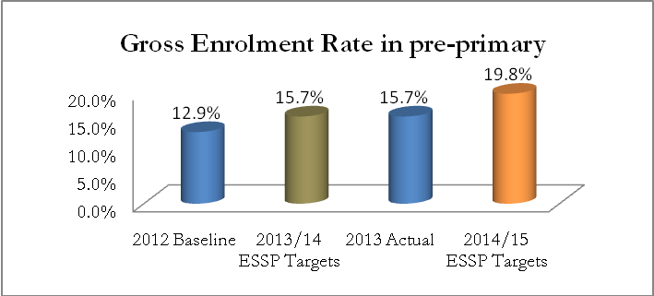
Likewise, the ESSP aims to increase the Net Enrolment Rate (NER) in pre-primary education from 12.7% in 2012 to 14.0% in 2013, and to 17% in 2014. However, the target was not met as the NER remained unchanged during the reporting period as is highlighted in graph 2 below.
Graph 2: Net Enrolment Rate in pre-primary education
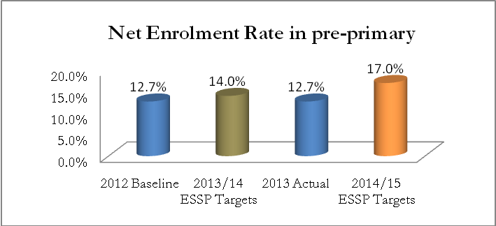
The observed discrepancy between the actual and ESSP target for 2013/14 could also be linked to the use of the current number of population from RPHC4, given that enrolment rates utilize population numbers in their denominator.

1.3. OTHER ACHIEVEMENTS
During the period under review, the sector has recorded a number of achievements in addition to those marked as ESSP 2013/14 – 2017/18 targets. Those include:
- 60% of primary schools have a pre-primary section
- 290 nursery schools were visited, 188 teachers inspected and given advice to improve learning and teaching processes, 45,339 textbooks were distributed in schools
- Pre-primary classrooms have been equipped with 9,568 desks, tables and chairs. The classrooms are being used while the remaining related finishing works such as painting, provision of water tanks, etc. are underway
- ECD kits were distributed to 1,260 pre-primary schools in all districts and ToTs on the use of those kits was organised whereby 55 trainers were trained.

CHAPTER 2: PROGRESS AGAINST ESSP OUTCOME “INCREASED EQUITABLE ACCESS TO 9 YEARS OF BASIC EDUCATION FOR ALL CHILDREN AND EXPANDING ACCESS TO 12 YEARS OF BASIC EDUCATION”

2.1. CURRENT SITUATION IN PRIMARY AND SECONDARY EDUCATION

2.1.1. Primary Education
Primary education is aimed to last six years, with the official school age at this level being from 7 to 12 years. This stage focuses on core literacy and numeracy skills, as well as on preparation for secondary studies. Primary education ends with national examinations which determine eligibility for proceeding to lower secondary education.
Since the introduction of 9 years basic education (9YBE) in 2009, primary education in Rwanda is fee-free. Since 2011, there has been an expansion to 12 years basic education (12YBE). This has positively impacted on increasing the number of enrolled pupils in this part of the education system.
During the reporting period, the number of pupils in primary schools has increased from 2,394,674 pupils in 2012 to 2,402,164 pupils in 2013. This represents a growth rate of 0.3%, as depicted in table 3 below.
Table 3: Number of pupils in primary education 2012 and 2013
Year | 2012 | 2013 | Variance | Growth Rate
Students | 2,394,674 | 2,402,164 | 7,490 | 0.3%
M | 1,180,484 | 1,183,306 | 2,822 | 0.2%
F | 1,214,190 | 1,218,858 | 4,668 | 0.4%
% of Males | 49% | 49%
% of Females | 51% | 51%

Similarly, the Ministry of Education has recorded a growth rate of 2.2% in the number of primary schools, as indicated in table 4 below.
Table 4: Number of schools in primary education in 2012 and 2013
Year | 2012 | 2013 | Variance | Growth Rate
Schools | 2,594 | 2,650 | 56 | 2.2%
Public | 675 | 678 | 3 | 0.4%
Gov. Aided | 1,738 | 1,762 | 24 | 1.4%
Private | 181 | 210 | 29 | 16.0%

It can be seen that there has been a significant increase in private schools and government-aided schools. This is a result of the Government of Rwanda’s significant efforts to encourage private sector investment in the education sector.

2.1.2. Secondary Education
A change is most evident in the enrolment of students in secondary schools, where the increment of 6% has been witnessed, as indicated in table 5 below. Between 2012 and 2013, the total number of students has increased from 534,712 to 566,370.
Table 5: Number of students in secondary schools in 2012 and 2013
Year | 2012 | 2013 | Variance | Growth Rate
Students | 534,712 | 566,370 | 31,658 | 6%
M | 255,503 | 268,581 | 13,078 | 5%
F | 279,209 | 297,789 | 18,580 | 7%
% of Males | 47.78% | 47.42%
% of Females | 52.22% | 52.58%

The significant increase in the number of students went hand in hand with the increase of the number of schools in this part of the education sector. As highlighted in table 6 below, the number of schools increased from 1,479 in 2012 to 1,515 in 2013, representing an increase rate of 2.4% during the period under review.
Table 6: Number of secondary schools in 2012 and 2013
Year | 2012 | 2013 | Variance | Growth Rate
Schools | 1,479 | 1,515 | 36 | 2.4%

2.2. PROGRESS AGAINST ESSP 2013/14–2017/18 MAJOR TARGETS

2.2.1. Primary Education
An important ESSP target is to decrease the primary Gross Enrolment Rate (GER) from 123.2% in 2012 to 121% in 2013 and 117% in 2014. Graph 3 below highlights the primary GER recorded during the period under review.
Graph 3: Primary Gross Enrolment Rate in 2012 and 2013
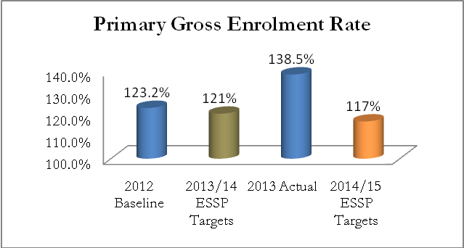
From the above graph, it can be seen that the primary GER has increased from 123.2% to 138.5% during the period under review. This indicates that there are many over-aged children in primary education due to delays in starting primary education or repetition across the years. It must be noted that the calculation of this year’s indicators was based on the newer population data from the RPHC4 (whereby the population is higher than according to previous projections). This is part of the reason for the wide discrepancy observed between these indicators and the ESSP 2013/14–2017/18 target of 121%.
A similar limitation is found in the comparison of indicators and targets for primary completion. A decrease from 72.7% in 2012 to 69% in 2013 is recorded (as evidenced on graph 4 below), meaning that the 2013 target of 74% was not met. This indicator is an example of the situation discussed above, where the denominator uses population statistics (in this case, population aged 12 in school year 2012), and where the data used for the calculation of 2012 baseline is based on population projections from 2002 census, whereas the calculations of the actual 2013 value are based on data from the new 2012 census.
Graph 4: Primary completion rate in 2012 and 2013
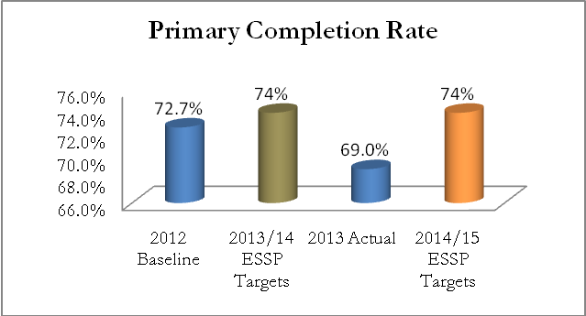
Although the GER has remained relatively high, primary education has registered an improvement in the Net Enrolment Rate (NER) throughout the reporting period, and since the 9YBE was kick-started in 2009. Since 2012, the NER increased from 96.5% to 96.6% (in 2013), approaching the target of 97% set under ESSP 2013/14-2017/18 for 2013.
Graph 5: Primary Net Enrolment Rate in 2012 and 2013
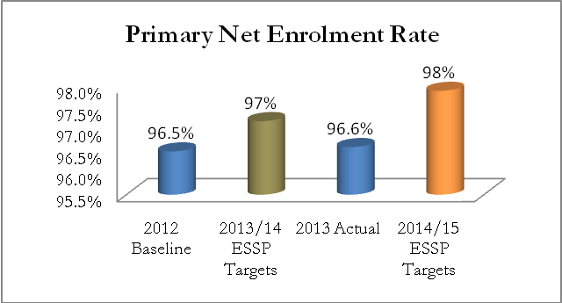
ESSP aims to increase the transition rate from primary to lower secondary; its targets are 74.4% in 2012, 86.8% in 2013, and 87.3% in 2014. The indicator values showing the current situation will be available after the 2014 school year.
On the other hand, the Ministry of Education recorded good progress in the provision of electricity, alternative energy and water to schools, though more efforts in this area are required for continued progress.
Graph 6 below shows the percentage of primary schools which had access to electricity during the reporting period.
Graph 6: % of primary schools with access to electricity
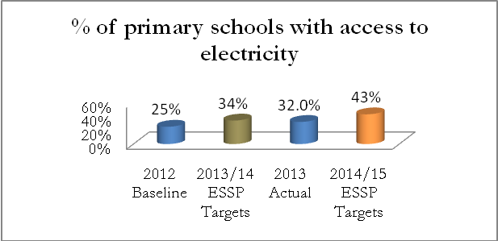
As per the graph above, there was an increase in the percentage of primary schools with access to electricity, from 25% in 2012 to 32% in 2013. The 2013 ESSP target of 34% was thus not quite met, but improvements were made in the right direction. Much more effort is required, however, to meet the ambitious target of 43% by 2014/15.
The percentage of schools with access to alternative energy sources remained unchanged at 9% throughout the period under review (as can be seen on graph 7 below). Given the 2013 ESSP target of 13%, the Ministry is unfortunately far from reaching its aims in this area. This is especially problematic given the ambitious 2014 target of 17%.
Graph 7: percentage of primary schools with access to alternative energy sources
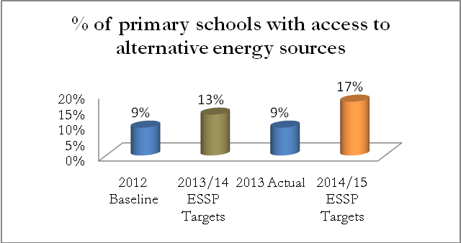
As to the provision of water, graph 8 below shows that there was an increase in the percentage of primary schools with access to water, from 34% in 2012 to 36% in 2013.
Graph 8: percentage of primary schools with access to clean water in 2012 and 2013
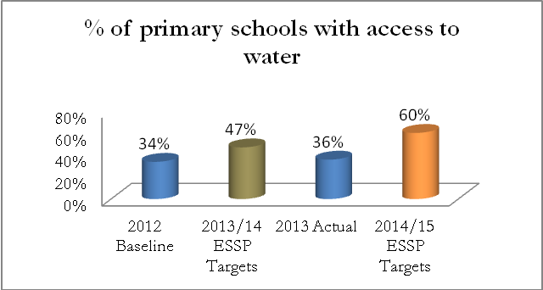

Considering the above information, it can be seen that the Ministry is still far from reaching the 2013 ESSP target of 47%.
The above analysis shows that more efforts are required in order to achieve the ESSP targets for 2014/15 – particularly with regards to reducing GER in primary schools.

2.2.2. Secondary Education
Secondary education lasts for six years, with the official age for this level being from 13 to 18 years. Crucially, secondary education is subdivided into lower secondary (the first three years) and upper secondary (the last three years). Both are concluded with national examinations, which determine eligibility for upper secondary and secondary graduation or entry to higher education, respectively.
i. Lower secondary education
In 2013, the number of students in lower secondary education increased significantly – from 352,796 in 2012 to 361,522. This increase (of 8,726 students) has been possible due to the implementation of 9YBE programme, including classroom construction and equipment, recruitment of teachers, and provision of books.
The lower secondary GER has slightly increased, from 49.2% in 2012 to 49.8% in 2013. However, it is still far from ESSP 2013/14 – 2017/18’s targets of 60% and 67% for the years 2013/2014 and 2014/2015, respectively.
Graph 9: Gross Enrolment Rate in lower secondary in 2012 and 2013
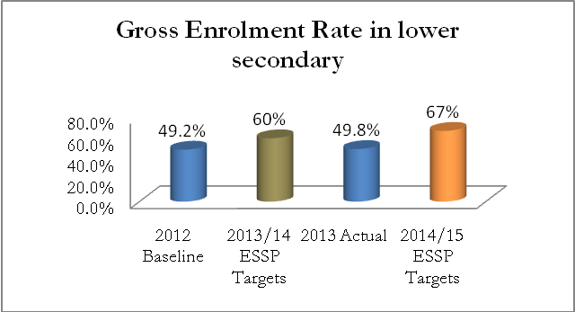
Similarly, the NER in lower secondary education has slightly increased, from 21.0% in 2012 to 22.7% in 2013, as indicated in figure 10 below.
Graph 10: Net Enrolment Rate in lower secondary in 2012 and 2013
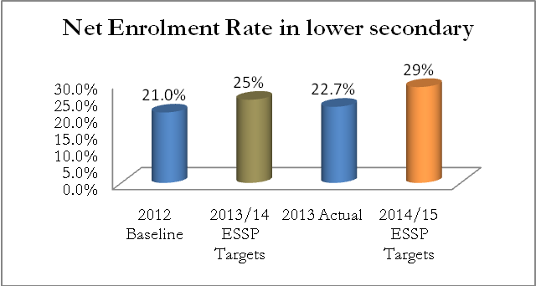
It can be seen that the 2013 target of 25% was not quite reached. The target for 2014 is 29%, and will require a lot of work to be achieved.
During the period under review, the Ministry of Education recorded a slight decrease in the transition rate from lower to general upper secondary – from 95.9% in 2012 to 95.3% in 2013. These changes are highlighted in graph 11 below.
Graph 11: Transition rate from lower to general upper secondary for 2012 and 2013
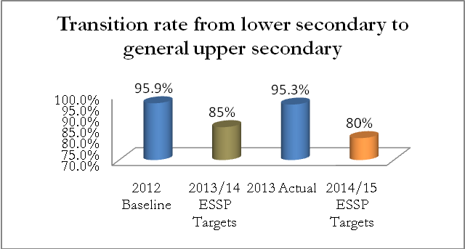
The above graph also shows that the targets for 2013 and 2014 are 85% and 80%, respectively. The fact that the 2013 target was not reached is not very problematic in this case, as the main goal of this targeted decrease is supposed be a simultaneous increase in TVET enrolment, which we can see has indeed taken place as planned. With time, the successful efforts to increase students’ enrolment in TVET will result in a significant decrease of the transition rate from lower to upper general secondary education.
ii. Upper secondary education
Figure 12 below shows that the GER in upper secondary education is recorded at 32.6% for 2013. The Ministry of Education thus surpassed the target of 28.1% for 2013, and even the target for 2014 (which is 29.1%).
Graph 12: Gross Enrolment Rate in upper secondary schools
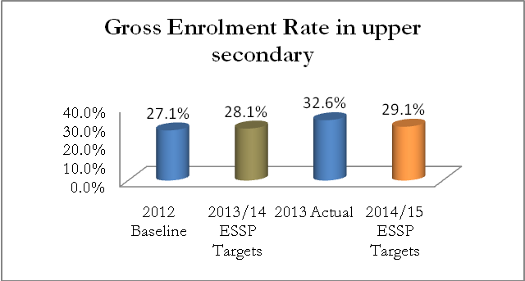
With regards to the Net Enrolment Rate in upper secondary education, graph 13 below shows an increase from 25.4% to 26.3% in 2012/13 and 2013/14, respectively.
Graph 13: Net Enrolment Rate in upper secondary education
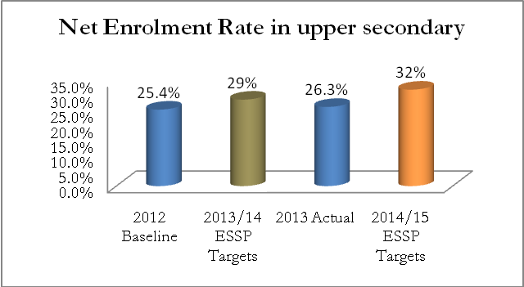
Compared to the ESSP targets of 29% for 2013/14 and 32% in 2014/15, the actual values for this indicator show that the sector is still far from reaching its goal.
Like in primary education, the Ministry of Education has recorded good progress in the provision of electricity, alternative energy sources and clean water to secondary schools. These achievements are indicated on graphs 14, 15 and 16.
Graph 14: % of secondary schools with access to electricity
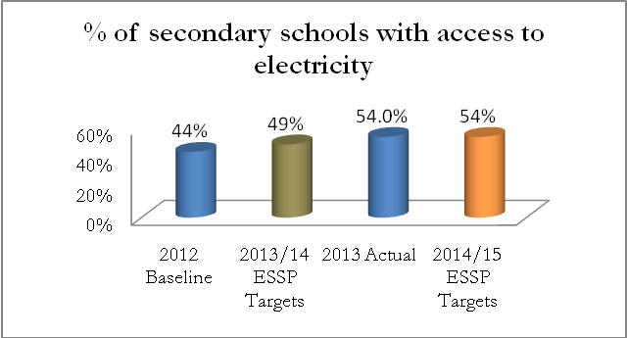
The Ministry of Education has recorded a significant increase in the percentage of secondary schools with access to electricity, surpassing the 2013/14 ESSP target of 49%. In fact, the achieved percentage is at the level of the ESSP target for the year 2014/15 (of 54%).
The percentage of schools with access to alternative energy sources stood at 18.6% in 2012. By 2013, this figure increased to 19%, approaching the 2013/14 ESSP target of 21%.
Graph 15: % of secondary schools with access to alternative energy sources
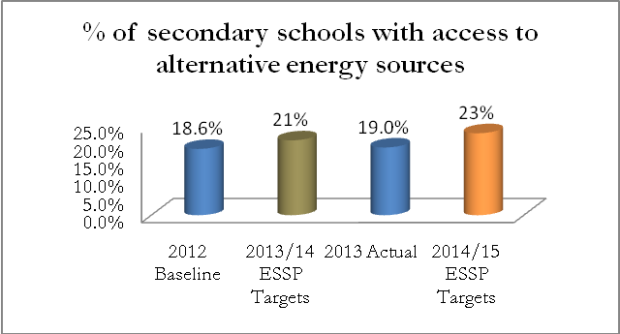
There was a more prominent increase in the percentage of secondary schools with access to water, from 45% in 2012 to 51% in 2013, as evidenced on graph 16 below.
Graph 16: Secondary schools access to clean water
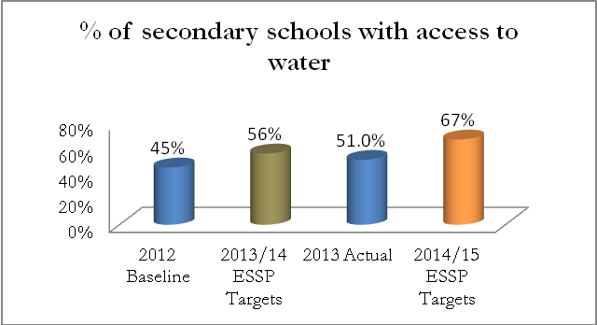

The ESSP targets for the percentage of secondary schools with access to water are 56% and 67% for 2012 and 2013, respectively. The Ministry of Education is thus on track to progress, but more concentrated efforts will be required to reach the 2014/15 target, given the discrepancy between the 2013 target and actual value.
Other important outcome indicators set under the ESSP 2013/14-2017/18 are pupils/classroom ratios and the number of primary pupils per class. A comparison of the targets and the actual status can be found in table 7 below.
Table 7: Comparison between pupils/classroom ratios and number of pupils per class with ESSP target
EDPRS and Sector Outcome Indicators | 2012 Baseline | 2013/14 ESSP Targets | 2013 Actual | 2014/15 ESSP Targets
Primary pupils: classroom ratio | 83:1 | 85:1 | 82:1 | 86:1
Primary pupils per class | 43:1 | 42:1 | 43:1 | 42:1
Lower secondary pupil: classroom ratio | 40:1 | 40:1 | 40:1 | 40:1
Upper secondary pupil: classroom ratio | 39:1 | 39:1 | 34:1 | 38:1
The education sector recorded a significant improvement in the primary pupils to classroom ratio (from 83:1 baseline to 82:1 in 2013), brought about by a significant effort to increase the number of classrooms. The reason for a higher ratio as target was that it was expected that increased enrolment would make it impossible to decrease this ratio, or even to keep it constant. However, the success of having an increased number of classrooms is expected to significantly contribute to improved teaching and learning in primary education. A similar improvement was recorded in upper secondary pupil to classroom ratio, which stands at 34:1 in 2013, when it was predicted that the ratio would remain at the baseline level of 39:1.

2.3. OTHER ACHIEVEMENTS
During the period under review, the Ministry of Education recorded significant achievements in primary and secondary education – these are discussed below.
Construction works were completed for 2,000 classrooms, 416 teachers’ houses and 2,964 latrines; this was conducted using both the public budget and an unconventional Rwandese method involving local population through community work ‘Umuganda’. Graph 17 below shows the number of every type of infrastructure constructed per province.
Graph 17: Statistics of classrooms, latrines and teachers hostels constructed per province
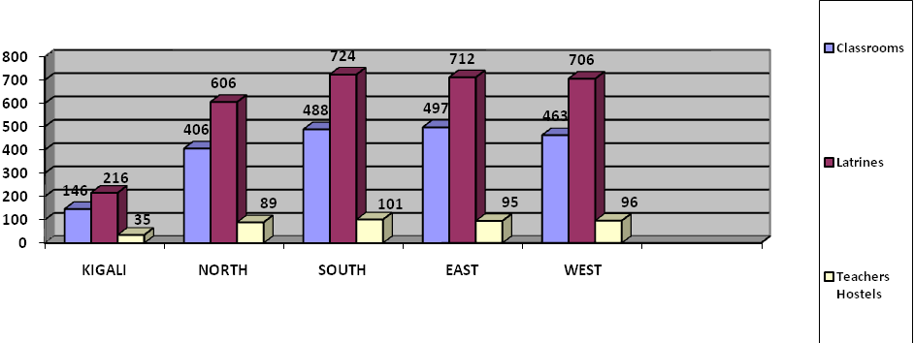
Further provisions for students include 46,000 desks, 2,000 chairs and 2,000 tables which now equip the newly constructed classrooms, as detailed in table 8 below.
Table 8: Number of desks for students, chairs and tables provided per province
Types of activities | Kigali | North | South | East | West | Total
Desks | 3,358 | 9,338 | 11,224 | 11,431 | 10,649 | 46,000
Tables | 146 | 406 | 488 | 497 | 463 | 2,000
Chairs | 146 | 406 | 488 | 497 | 463 | 2,000
The Government of Rwanda is committed to gender equality across all aspects of Rwandan life, and girls’ education initiatives are a crucial part of that commitment. Girls’ education is a central component of strategies to ensure that there is inclusive basic education for all, and beyond basic schooling to ensure that women are appropriately skilled to contribute positively to economic and social development.
In collaboration with CARE International Rwanda, through the project Keeping Girls at School (KGAS), 6,078 girls were supported through mentorship in order to address their social, emotional and economic challenges. A saving system was put in place to help girls in obtaining small investments in Gisagara and Nyamagabe districts.
In addition, in a bid to strengthen girls’ education and reduce their absenteeism at all levels of education, 1,207 schools were equipped with hygiene facilities including sanitary pads.
In order to improve the learning environment, School Health Policy has been developed with the vision: “all Rwandan school children shall achieve their full development potential, by studying in a healthy environment in child-friendly schools, free from disease, prejudice and violence”. After the approval of the policy, the following activities were carried out:
- The School Health Policy was disseminated to stakeholders (teachers, DEOs, SEOs) in 6 districts;
- 1,800 school health minimum package copies were produced and provided to schools;
- 29 schools were visited in order to evaluate the implementation of school health programmes;
- 511 teachers were trained in HIV/AIDS, adolescent sexual and reproductive health and nutrition, in order to acquire the necessary skills to teach students and other teachers;
Photo 1: Teachers’ training in HIV/AIDS, adolescent sexual and reproductive health and nutrition in Nyamagabe District

- A national, community-owned school feeding programme has been established in all 9YBE and 12YBE schools.
In sport and culture, 240 coaches were trained in all districts in various games, such as basketball, netball and handball. Various competitions were organised at various levels (from school to national level) and as a result, 12 teams were selected to represent the country in the Federation of East Africa Secondary School Association (FEASSA).
In line with teacher development, the ministry transferred an amount of 1,000,000,000 Rwf to the account of the teacher cooperative Umwalimu Sacco, to then be further allocated among districts by the cooperative. This initiative has as its goal the improvement of the social welfare of teachers.
The Ministry of Education apportioned and earmarked funds for all districts to support children from needy families and to roll out the catch-up program. An amount of 42,000,000 Rwf has been earmarked for 16 districts that accommodate 52 catch-up schools; each district received a part of this total, the relative amounts being based on the number of centers in the district.
In the 2013/14 fiscal year, an amount of 45,000,000 Rwf was provided for the support of needy students at the district level, benefiting 4,160 pupils.
At the national level, 26 students from 20 secondary schools were given awards during the national award ceremony.
Regional integration was supported by Rwanda’s participation in the 2013 EAC essay-writing competition, which is organized every year in secondary schools for S1 and S2 students. In 2013, 103 secondary schools were invited to participate in the competition, from which 381 students’ essays were collected. All collected essays were marked and the five best students were accompanied to the regional award ceremony in Kampala, Uganda.
During the 2014 EAC essay-writing competition, participation was increased to 288 secondary schools. Information materials and competition guidelines were distributed in those schools.

2.4. CHALLENGES
As indicated in the ESSP 2013/14-2017/18, most of schools and learning institutions are not adequately equipped with appropriate facilities, learning and teaching materials. There is an insufficient amount of teachers adequately trained in order to be able to integrate children with special needs into their classroom activities. Ensuring that all schools in Rwanda are child-friendly and disabled-friendly is a challenge which has to be further addressed. Special schools for children with more severe disabilities also need to be effectively resourced and supported.
Whilst in general, Rwanda can boast of gender equity in access to basic education, some challenges remain with regards to girls’ performance. Similarly, there is a need to support girls who wish to study science and technology, including some fields of TVET and higher education, as highlighted by the ESSP.

2.5. RECOMMENDATIONS
To address the above challenges, the Ministry of Education is recommended to increase the efforts dedicated to strategies targeted to promote child-friendly schools. These include, but are not limited to:
- strengthening gender-sensitive and learner-centred methodologies;
- training of educationists, trainers and education planners in gender issues and other cross-cutting programs;
- regular review of education curricula and learning materials;
- sensitising families and local communities to the importance of education of girls and children with disabilities;
- promoting affirmative action policies, where appropriate, to ensure equal opportunities;
- strengthening integration of girls’ education into plans and budgets at all levels.

CHAPTER 3: PROGRESS ON IMPROVED QUALITY AND LEARNING OUTCOMES ACROSS PRIMARY AND SECONDARY EDUCATION

3.1. INRODUCTION
An important challenge for the sector remains the need to address the quality of education throughout the system. There is now a great opportunity to approach the 12YBE reforms from a holistic point of view, addressing the issues of quality improvement and increased access side by side in order to ensure an optimum balance between them.
Relevant improvements include reductions in average class size and pupil-teacher ratios, an improved curriculum supported by better and more readily available teaching and learning materials, and improved examination and assessment systems.

3.2. PROGRESS AGAINST ESSP MAJOR TARGETS
The figures and discussion below illustrate the progress against ESSP major targets with regards to education quality and learning outcomes.
Graph 17: Primary school repetition rate, actual and ESSP targets
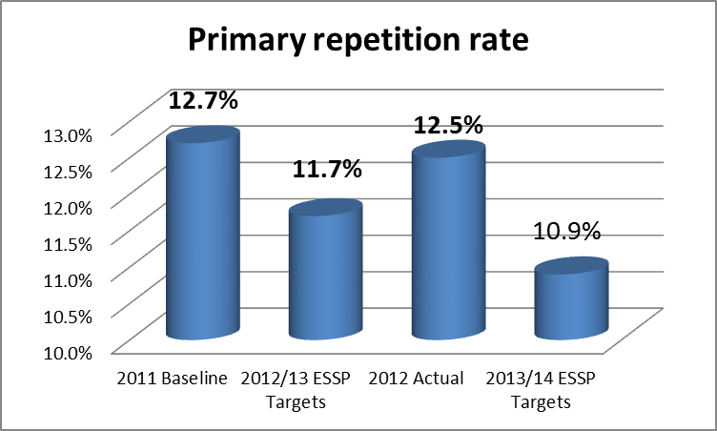
The figure above shows that there was a decrease in the primary repetition rate, from 12.7% in 2011 to 12.5% in 2012. However, this decrease was not enough to achieve the target for 2013 (11.7%). The 2014 target is even more ambitious, at 10.9%. These higher than targeted repetition rates can be connected to the problem of overly high GER in primary education. Targeting the repetition rate is necessary in order to improve the GER in this level of education.
Graph 18: Primary school dropout rate, actual and ESSP targets
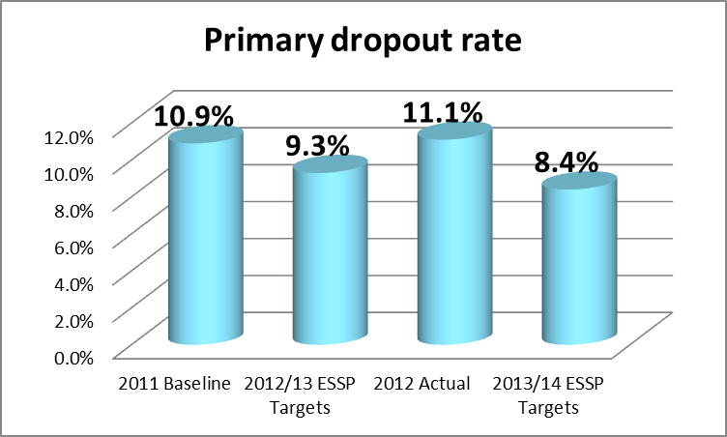
The figure above illustrates that the primary dropout rate increased from 10.9% in 2011 to 11.1% in 2012. The 2013 ESSP target was 9.3% and the 2014 target is 8.4%. The primary dropout rate must be tackled as a priority for the improvement of the quality of Rwanda’s basic education.
Graph 19: Lower secondary repetition rate, actual and ESSP targets
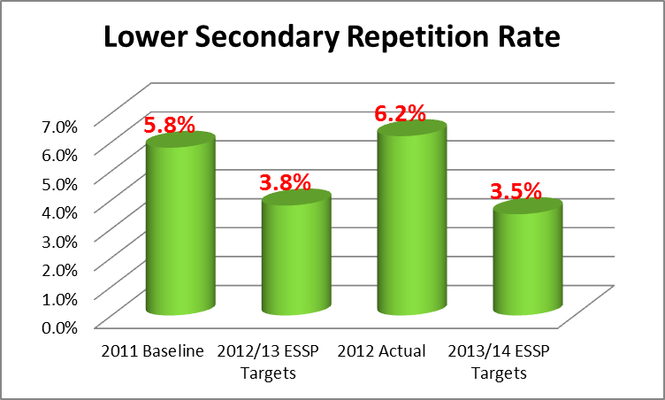
The figure above illustrates that the repetition rate for lower secondary schools increased from 5.8% in 2011 to 6.2% in 2012. The target for 2013 was 3.8% and the 2014 target is 3.5%. The given data thus shows that significant challenges are prevalent in lower secondary education, as well.
Graph 20: Lower secondary dropout rate, actual and ESSP targets
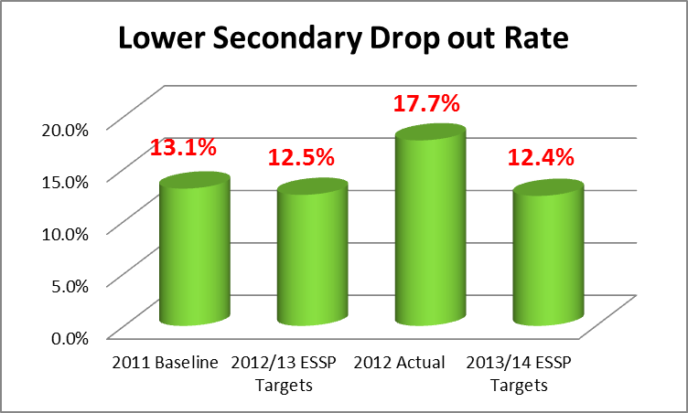
The figure above indicates that there was an increase in the lower secondary dropout rate, from 13.1% in 2011 to 17.7% in 2012. The 2013 target of 12.5% was not reached, and the target for 2014 (12.4%) can only be hoped to achieved with clear and concentrated efforts.
Graph 21: Upper secondary repetition rate, actual and ESSP targets
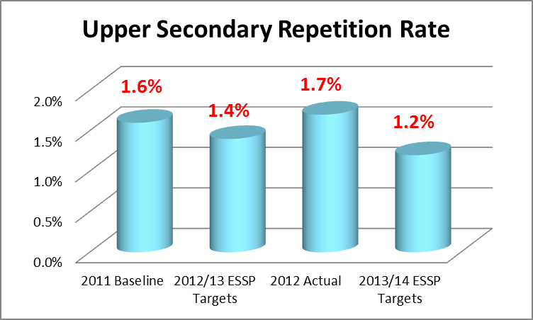
The figure above illustrates that in upper secondary education, the repetition rate increased slightly, from 1.6% in 2011 to 1.7% in 2012. The 2013 ESSP target was 1.4% and the 2014 target is 1.2%. This shows that the 2013/14 target was not met, which will make it difficult to meet the ambitious 2014/15 target.
Graph 22: Upper secondary dropout rate, actual and ESSP targets
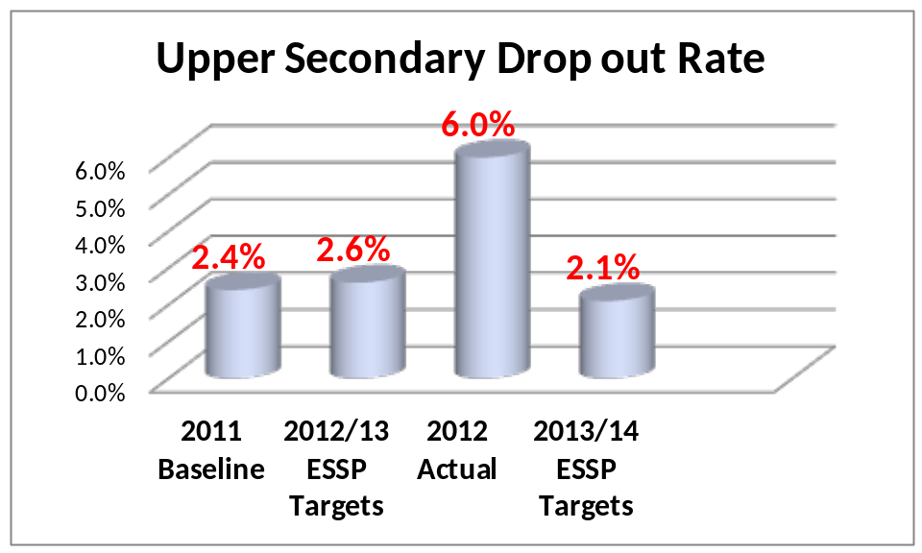
As shown in the figure above, the dropout rate in upper secondary education increased to 6.0% in 2012, which compared to the ESSP target from that year (2.6%) and the 2014/2015 target (2.1%), is indeed a problematic value.
In general, basic education dropout and repetition rates have shown problematic trends in the year 2013, and there is a need to conduct a study to analyse the causes of and find remedies for these specific challenges. These issues need to be taken seriously, also where planning and budgeting is concerned. However, as mentioned previously, the use of new population data as the denominator can be a partial cause of these trends; this reinforces the idea that a deeper analysis of the situation is required.
Graph 23: Library situation in primary schools
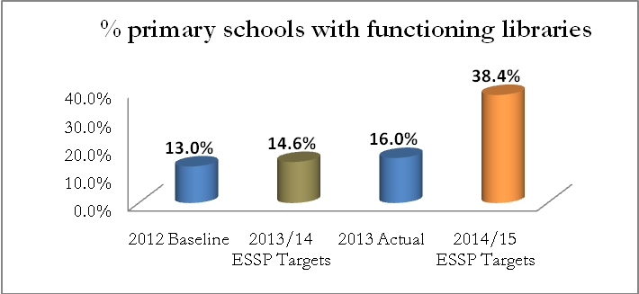
The above figure shows that the 2013 target of 14.6% was surpassed with regards to the percentage of primary schools with functioning libraries. This percentage increased from 13% in 2012 to 16% in 2013. The 2014 target is at the ambitious level of 38.4%, but the sector is well on track due to exceeding the previous target.
Graph 24: Library situation in secondary schools
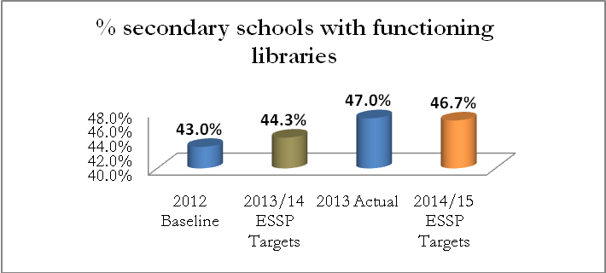
The percentage of secondary schools with functioning libraries increased significantly from 43% in 2012 to 47% in 2013. The target of 44.3% was thus surpassed for 2013. The 2014 target is 46.7%, which will most likely be reached.
Graph 25: Percentage of students passing national S3 exams
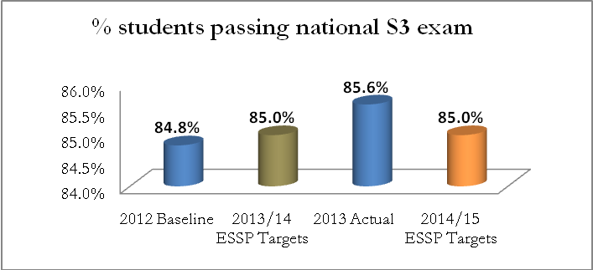
The 2013 target of 85% for the percentage of students passing the national S3 exam was also surpassed, with an increase from 84.8% in 2012 to 85.6% in 2013. The 2014 target is also 85%, so this indicator of quality of secondary education shows better results than expected.
Graph 26: Percentage of students passing national S6 exams
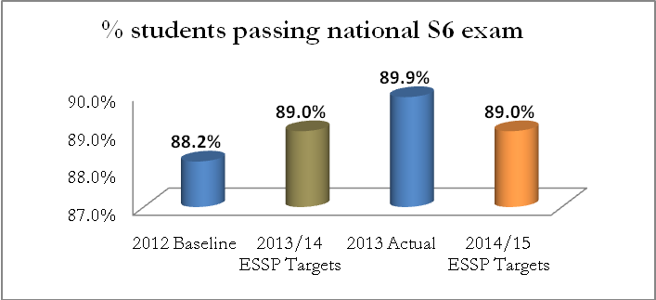
The above figure shows that there was an increase in the percentage of students passing the national S6 exam from 88.2% in 2012 to 89.9% in 2013. The 2013 target of 89% was thus surpassed; the 2014 target is also 89%.

3.3. OTHER ACHIEVEMENTS

3.3.1. Primary level
Additional initiatives conducted in 2013/14 at the primary level include:
- visiting of 554 primary schools, inspection of 833 primary teachers, to whom advice was given on how to improve the quality of education;
- distribution of 664,768 textbooks and 267,004 supplementary materials to schools. Reprinting of the curriculum of Music in 6000 copies to equip schools;
- training of 484 primary teachers from Ngoma, Rwamagana, Gisagara, Nyabihu, Karongi and Musanze districts on the use of science kits in schools;
- training of 148 teachers of entrepreneurship education from Gakenke, Burera and Musanze districts in Entrepreneurship Education (in December);
- the activity of the curriculum review is in process. Its goal is to design a competency-based curriculum which focuses on higher order thinking skills and deeper understanding relevant to the students' lives and needs of the nation, with smooth progression across the levels.

3.3.2. Lower secondary level
Additional initiatives conducted in 2013/14 at the lower secondary level include:
- distribution of 347,199 textbooks and 84,757 supplementary materials to schools;
- reprinting of French and Agriculture curricula in 2000 copies each, in order to equip schools.

3.3.3. Upper secondary
Additional initiatives conducted in 2013/14 at the upper secondary level include:
- visiting of 679 secondary schools; provision of advice to 789 teachers;
- distribution of 189,661 textbooks and 11,315 supplementary materials to schools.

3.3.4. Examinations statistics and performance
Several achievements were recorded with regards to national examinations.
At the primary level, 163,092 candidates in total sat the 2013 Primary National Examinations. Of these, 54.89% (89,537 candidates) were female. The pass rate for all candidates increased since the year before. In 2013, 135,563 candidates (83.12% of those sitting) passed the exams, while the pass rate in 2012 was at 83.09%. This is an extremely slight increase, but it shows a lack of regression. Of the candidates who passed, 54.05% were female, which corresponds closely to the ratio of candidates enrolled to sit the exam – thus, girls sitting the exams pass them with a very similar success rate to the boys who sit the same exams.
In lower secondary education, 93,889 candidates sat Ordinary Secondary National Examinations with a pass rate of 85.14% (79,937 candidates passed). This is an increase in both the amount of candidates (from 81,053 sitting in 2012) and in the pass rate, which stood at 84% in 2012. The 2013 pass rate for candidates in those examinations also surpassed the 2013 ESSP target of 85%. Of all candidates sitting those exams, 52.79% were female, and of the candidates passing them, 50.28% were female.
This paragraph discusses Upper Secondary National Examinations, which are not the same as national S6 exams discussed above, because they do not include TSSs and TTCs. The number of candidates who sat Upper Secondary National Examinations in 2013 is 31,125, of which 50.8% were female. 27,330 candidates, or 87.8% of those sitting, passed. There has been a decrease in candidates sitting these exams, from 32,233 in 2012. The pass rate is much higher than the 2012 baseline and the 2013 ESSP target, making this rate of achieving the qualification for advanced level certificate the biggest achievement in the 2013 examinations. Of the candidates who passed, 48.41% were female. Table 9 below shows more details about these examinations.
Table 9: Upper secondary students' performance for 2013
 | Registered candidates |  |  | Candidates who sat for exams |  |  | Absentees |  |  | Passed
Sex | School candidates | Private candidates | Total | School candidates | Private candidates | Total | School candidates | Private candidates | Total | School candidates | Private candidates | Total
F | 15,011 | 788 | 15,799 | 14,900 | 713 | 15,613 | 111 | 75 | 186 | 12,992 | 239 | 13,231
M | 14,702 | 624 | 15,326 | 14,600 | 537 | 15,137 | 102 | 87 | 189 | 13,795 | 304 | 14,099
Total | 29,713 | 1,412 | 31,125 | 29,500 | 1250 | 30,750 | 213 | 162 | 375 | 26,787 | 543 | 27,330
Candidates who sat for exams represented 98.8% of candidates who registered, meaning that 1.2% of candidates who registered did not sit for exams. The candidates who qualified for certificates represented 88.8% of those who sat the exams, and of these, 48% candidates were female. Furthermore, 95.9% of the candidates who sat the exams were school candidates while the remaining 4.1% were private candidates.

CHAPTER 4: CHANGES IN INCREASED EQUITABLE ACCESS TO EDUCATION FOR STUDENTS WITH SPECIAL EDUCATIONAL NEEDS WITHIN MAINSTREAM AND SPECIAL SCHOOLS

4.1. INTRODUCTION
The Ministry of Education is committed to putting in place the necessary provisions and support for the education of the educationally vulnerable children and youth. Providing education for children with disabilities and special educational needs is an important pillar for promoting social inclusion within Rwanda and for achieving our educational goals of equitable access to basic education for all. The cross-cutting issue of access and participation of children with disabilities is one of the key challenges for the sector and has thus been prioritised as one of the ten strategic outcome areas for the ESSP.

4.2. PROGRESS AGAINST ESSP MAJOR TARGETS
There are three major sector outcome indicators related to special needs education. These are:
- the number of children with disabilities enrolled in primary and secondary schools;
- percentage of schools with disabled-friendly facilities for special needs;
- the total number of teachers who have received in-service training on teaching students with special educational needs.
Of the above mentioned indicators to be reported, data for the one related to the percentage of schools with disabled-friendly facilities for special needs are not yet available.
In terms of enrolment, graph 28 below shows that during the period under review, there has been a decrease in number of children with disabilities enrolled in primary and secondary schools.
Graph 27: Trend in children with disability in primary and secondary schools
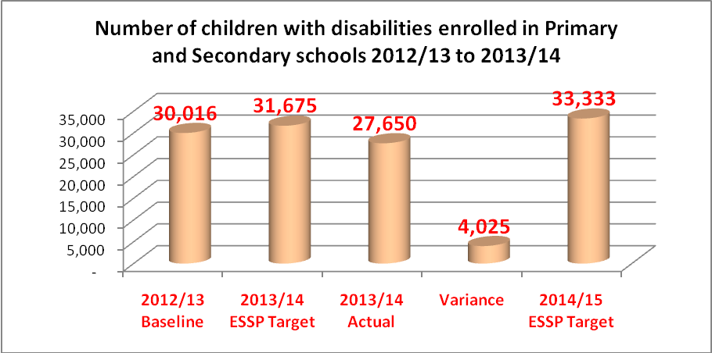
The graph above shows that the number of children with disabilities enrolled in primary and secondary schools decreased from 30,016 in 2012/13 to 27,650 in 2013/14. The variance between ESSP target and current situation is significant (4,025), which shows the need for more efforts to be directed towards the achievement of the 2014/15 ESSP target of 33,333.
In order to increase equitable access to special needs education programme, the following activities have been carried out:
- 6 schools were supported to construct and renovate infrastructure and equipment materials, in the framework of increasing access and improving school environment;
- 515 teachers from different schools have been trained in different domains of SNE: trainings in sign language and methodology of teaching the deaf, teaching learners with visual impairment and basics in Braille reading and writing. Graph 29 below shows the number of teachers trained in different domains of SNE.
Graph 28: Number of teachers trained in Special Needs Education
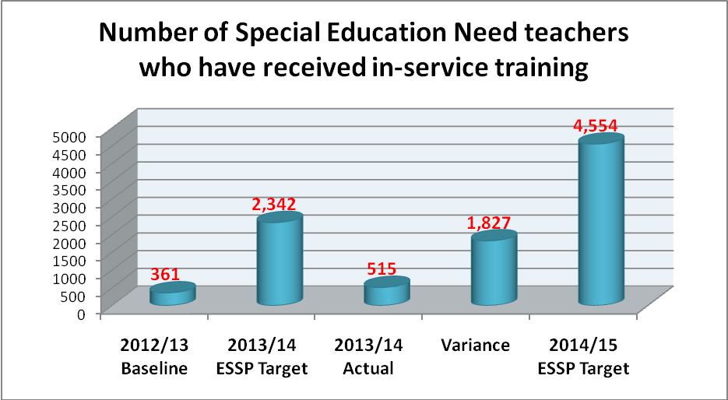
The above graph indicates that the total number of SNE teachers who have received in-service training on teaching students with special educational needs increased from 361 in 2012/13 to 515 in 2013/2014, which is an increment of 154. The 2013/14 ESSP target of 2,342 was thus much higher than the actual amount of teachers who have received the training; the target was not met due to budget constraints.
Other achievements include providing wheelchairs to children with mobility problems, in collaboration with HI and ADRA 97.

CHAPTER 5: EFFORTS AND RESULTS IN PROVIDING QUALIFIED, SUITABLY-SKILLED AND MOTIVATED TEACHERS AND TRAINERS TO MEET DEMANDS OF EXPANDING EDUCATION ACCESS.

5.1. INTRODUCTION
Teachers and trainers are the backbone of the education system; their motivation has a strong impact on the overall quality of the system and the learning outcomes of pupils and students. Preparation and recruitment of highly skilled teachers is envisaged as the appropriate way to meet the targeted reductions in the pupil-teacher ratio for both primary and secondary level. The introduction of the innovative school-based mentoring programme underpins one of the sector’s approaches to improving the skills of teachers. The English language proficiency and teaching methodology, combined with a strengthened pre-service system, will help to build a skilled and well-qualified teaching force. The implementation of a continuous professional development system, combined with the use of a more effective teacher development and management information system, will help to motivate the teaching workforce and will support more efficient teacher recruitment, deployment, promotion and in-service training mechanisms.
Graph 30 (below) illustrates the number of qualified teachers and staff in primary and secondary schools in 2013-2014.
Graph 29: Qualified staff situation in primary and secondary schools
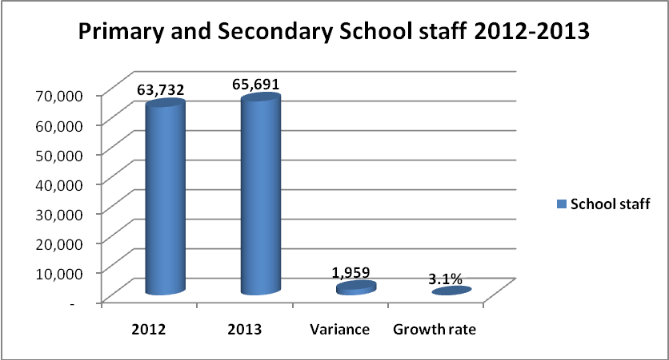
The number of staff in primary and secondary education levels stands at 65,691 in 2013, which is an impressive improvement from 63,732 staff recorded in 2012. This is due to the deliberate initiatives of teacher recruitment.
Graph 30: Qualified teacher numbers in primary and secondary schools
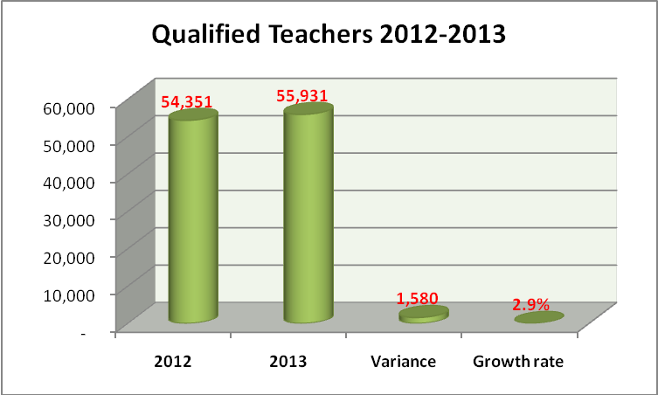
Likewise, the number of qualified teachers in this part of the education system continues to increase as a result of 12YBE implementation efforts. As can be seen in the figure above, the number of qualified teachers has increased from 54,351 in 2012 to 55,931 in 2013, representing a growth rate of 2.9%.

5.2. PROGRESS AGAINST ESSP TARGETS
The Ministry of Education has to ensure that students are equipped with the skills required on the job market. This is attempted through improving the ratio of primary and secondary pupils to qualified teachers, as detailed in table 10 below.
Table 10: Primary and secondary schools/qualified teacher ratio
Year | 2012/13 baseline | 2013/14 target | 2013 actual | 2014 /15 target
Primary Pupil/Qualified Teacher Ratio | 62:1 | 58:1 | 63:1 | 55:1
Secondary Pupil/Qualified Teacher Ratio | 32:1 | 31:1 | 32:1 | 30:1
The primary pupil/qualified teacher ratio stands at 63:1, which means that the ratio has increased since 2012, when it was at 62:1. In secondary education, the ratio has increased from 31:1 to 32:1. This indicates that the Ministry of Education has to significantly increase its efforts in training and recruitment of qualified teachers in order to meet 2014/15 ESSP targets of 55:1 and 30:1, in primary and secondary education levels, respectively.

5.3. OTHER ACHIEVEMENTS
In order to motivate teachers, additional activities were performed. These achievements include:
- 416 houses were constructed, designed to accommodate 3,248 teachers;
- 1,342 A2 teachers were trained in Maths and Sciences;
- 621 new deputy head teachers were trained in school management and leadership;
- 400 SEOs were trained in the new approach on coaching school leaders to achieve high level of learning outcomes and facilitation of head teachers;
- 5,486 school administrative staff including head teachers, deputy head teachers in charge of studies and deputy head teachers in charge of discipline, as well as secretaries and bursars, attended peer learning session to share the best learning practices and experiences;
- 145 cows were given to best performing teachers;
- as part of the monitoring and evaluation activity aimed at setting the number of calves born in all districts, 131 calves were identified and given back to other best performing teachers;
- 30 teachers were awarded with Laptops;
- 59,934 teachers had been given a total amount of 27,184,986,091 francs as loans up to 2013/14;
- Umwalimu SACCO was supported with 1bn francs;
- 1000 mentors recruited and deployed in schools since the start of the programme; 108 mentors recruited in period under review.

CHAPTER 6: PROGRESS ON THE ESSP OUTCOME “INCREASED EQUITABLE ACCESS TO RELEVANT, HIGH-QUALITY, DEMAND-DRIVEN TVET PROGRAMMES”

6.1. INTRODUCTION
As identified in the country’s vision 2020, one of the pillars of continued growth is human resource development. In order to provide a strategic response to the challenges found on the way to skills development across all sectors of the economy, the Government of Rwanda has created the Workforce Development Authority (WDA), an institutional framework working under the Ministry of Education. The main Mission of WDA is to promote and guide the development and upgrading of skills and competencies of the Rwandan workforce, in order to enhance its competitiveness and employability through Technical and Vocational Education and Training (TVET).

6.2. PROGRESS AGAINST ESSP MAJOR TARGETS
During the period under review, students’ enrolment in TVET programmes increased from 74,320 students in 2012 to 83,893 students in 2013, as indicated on graph 32 below. Given that the target for 2013 was 86,814 students, more efforts are required to encourage students completing S3 to enroll in TVET programmes (especially if the ambitious 2014/15 target is to be achieved).
Graph 31: TVET enrolment, actual and targets
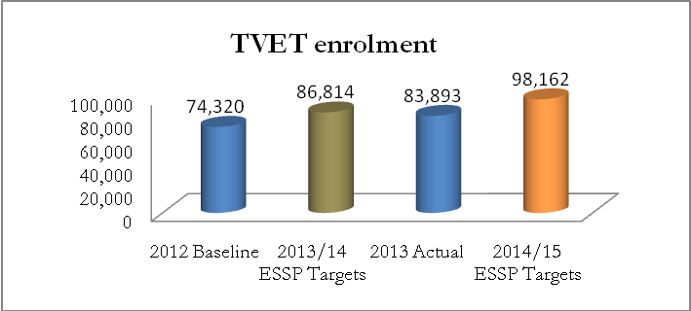

6.3. OTHER ACHIEVEMENTS
Over the fiscal year 2013/14, the WDA has been implementing its mandate through various initiatives based on the three ESSP pillars: access, quality and relevance. In order to expand access to vocational and technical education, WDA has been developing TVET infrastructure and upgrading the existing TVET schools, including the provision of training equipment and teaching materials, and increasing the number of trainees who join the TVET system. Currently WDA records 340 TVET schools (9 Integrated Polytechnic Regional Centres (IPRCs) and polytechnics, 167 technical secondary schools (TSSs) and 164 vocational training centres (VTCs)) across the country, out of which 12 were newly constructed during the period under review.
The production of training modules and curricula development has been centred on the Competence-Based Training (CBT) approach. Currently, a total of 40 CBT TVET curricula are in place, of which 10 were developed during 2013/14 fiscal year. The recruitment of trainers and upgrading of their skills constitute a core responsibility of WDA. So far, there are 2,909 trainers in TVET system and about 358 of these were trained in the fiscal year under review.
The introduction of Industrial Based Training (IBT) approach is a success story that MINEDUC is proud to share. WDA and its partners recently initiated IBT; the initial phase started with the hospitality sector. Currently, there are 416 trainees and 4 hotel training sites under the Skills Development Project (DSP).
Under the Skills Development Fund (SDF) initiative of quick skills delivery (conducted in partnership with World Bank), over 37 TVET training providers and companies have been funded to take part in skills development in different training fields. So far, over 1,200 youth beneficiaries have been empowered and certified.
In partnership with TVET stakeholders, various activities have been accomplished, including: the construction of 5 TVET schools in western province (in partnership with Swiss Agency for Development and Cooperation), the renovation of 6 schools under SDP, and the construction of a Learning Complex going on in IPRC-Kigali in support with Kuwait fund Project, among others.
In partnership with the Chinese government, IPRC-North (Musanze Campus) construction had been undertaken, and is now in its final phase. With the support of KOICA in IPRC Kigali, support has been provided to the Information and Communication Technology (ICT) centre, ToT centre and multiple workshops. Under PFAP, staff capacity building is being strengthened in 24 TVET schools. Moreover, with the support from JICA, Tumba College of Technology has been strengthened, especially in terms of academic staff capacity building.
In the process of assurance and improving the quality of TVET delivery, WDA has put in place training standards and specific requirements for training facilities. Furthermore, at least 200 TVET schools have been inspected for quality assurance. CBT and assessment approach have been rolled out in TVET schools, prior to their upcoming nation-wide expansion.
In terms of strengthening the relevance of education and training to meet labour market demands, private sector/industry involvement in curricula development and TVET skills delivery have been crucial. The ongoing up-scaling of Industrial Attachment Practice to all 340 TVET schools is helping TVET graduates to make their skills more relevant to the labour market.
The establishment of Sector Skills Council (SSC) was put into effect and 7 SSCs are in place thus far, bringing private sector on board for the task of making TVET more demand-driven.
Moreover, WDA has initiated employment market data inflow from LMIS through TVET-IS and annual tracer surveys (checking employer satisfaction and absorption of graduate trainees) for a better monitoring of the quality and relevance of TVET. Table 12 provides an overview of the main achievements of TVET programmes.
Table 11: Main achievements of TVET programmes
S/N | TVET Sub-programs | Baseline (2012/13) | Progress (2013/14) | Observation
1 | Competence Based Curriculum (CBC) | 25 | 40 | More 15 CBC have been developed
2 | Training of Trainers (ToT) on Competence Based Training (CBT) | 20 | 296 | More trainings planned for 2014/15
3 | Examination and certification | 17223 | 21600 | About 99% of students are expected to sit for exam
4 | TVET Schools development (TSD) | 16 | 21 | About 21 schools have been rehabilitated or renovated
5 | Supply of Equipments to TVET schools | 35 | 69 | The number of schools supplied with equipments increased by 34
6 | TVET Awareness Campaign (TAC) | 4216 | 5321 | The TVET Expo attracts more people annually
7 | Industrial Based Training (IBT) | NA | 416 | The IBT started in 2013/14 in hospitality sector
8 | Industrial Attachment Programme (IAP) | 9123 | 12231 | The number of internees increased by 7%
9 | Accreditation and Quality Assurance | 220 | 123 | More than 100 TVET schools are inspected every year.
10 | TVET Enrolment | 73,681 | 83,893 | The No of trainees increased by 12%
From the above table it can be seen that significant progress has been made in various key TVET sub-programmes during the fiscal year 2013/14.
There has also been a significant increase in the number of TVET schools since 2010, as detailed in table 12 below.
Table 12: Trend in TVET schools from 2010-2013
Type of schools | Academic Years
Type of schools | 2010 | 2011 | 2012 | 2013
TSS | N/A | 156 | 151 | 167
VTC | 61 | 98 | 126 | 132
IPRCs + Other Polytechnics | 2 | 2 | 5 | 9
Total | - | 256 | 282 | 308
In 2013, there were 308 TVET providers in total, representing a growth rate of 8% compared to the situation in 2012.
During the reporting year, the government continued encouraging private sector to come on board and invest in TVET skills development in order to meet the labour market needs. Graph 33 below illustrates the shares of TVET programmes provided by the different agents.
Graph 32: % of TVET schools per providers
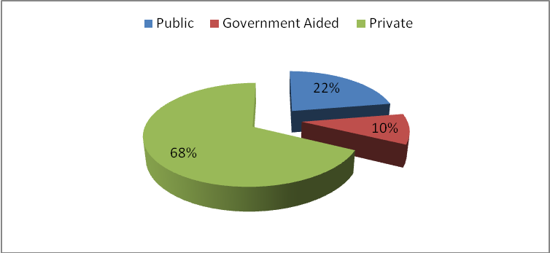
From the above graph it can be seen that 68% of TVET providers are private investors, 22% are public and 10% are government-aided.
In terms of training of trainers, WDA and its development partners put significant effort into building the capacity of trainers. The Technical and Vocational Schools Association in Rwanda (TVESA) in collaboration with GIZ in May 2014, held a one day workshop for 150 trainers from TSSs and VTCs from across the country.
Furthermore, a national ToT upgrade for TVET in-service and in-company trainers in CBT and assessment was concluded in December 2013 at Groupe Scolaire MATER DEI in Nyanza district (southern province).
In examination and certification, in 2013 the number of candidates who sat for technical and professional national exams has increased from 17,428 to 21,818 (25.5% increment), the number of examined subjects increased from 108 to 114 (5.56% increment), while the overall pass rate increased from 90.95% to 91.01% (0.06% increment). Out of the 19,674 candidates who passed, 318 (63.86%) were private candidates, while 19,356 (91.65%) were school candidates. Of all the candidates, 49.5% were female.
In terms of provision of training materials and equipment to TVET schools, during the period under review, WDA donated over 4338 course books to TVET schools around the country.
In TVET Awareness Campaign, a nationwide campaign was organised by WDA through local artists to raise TVET awareness in December 2013. This attracted thousands of people from different district; it started with competitions to select students who will join the new school of music (School of Arts of Music in Nyundo) and proceeded towards a sensitisation of locals to the existence of the Skills Development Fund within WDA.
The Ministry of Education also called for more innovations through TVET, as the country aims to create 200,000 off-farm jobs per year. This call was made while officially closing the 2013 TVET Expo that started on 28th November, 2013; this expo attracted over 5000 visitors.

Photo 2: The Minister of Public Service and Labour Anastase Murekezi, and the Minister of Disaster Management and Refugees, Séraphine Mukantabana, observing a tire water pump operated by an exhibitor from IPRC-Kigali.
In December 2013, the Tumba College of Technology celebrated the award of being among the East African centers of excellence in promoting TVET, research, ICT, culture, language and tourism.
In the process of promoting TVET skills, in June 2014, 48 trainees graduated in high level cloth fabrication at Gaculiro VTC (Kigali) (with the support of Reborn Kyoto), after a 10 month training course in making Japanese clothes (kimonos) and different styles of garments. In the same month, 112 trainees completed training in Culinary Art and Food Processing at Saint Philip Technical Secondary School located in Kicukiro district. Certificates were awarded to 80 students who completed three month training in Culinary Art through support from the Skills Development Fund.
Gacuriro VTC received a grant of 43 million Rwf in the second round of the Skills Development Fund grants in 2013, due to its successful presentation of a project on “Training people to provide motor rewinding services, a skill that is still rare among Rwandans”. Over 700 million Rwf was awarded to 20 winners engaged in different training fields.
WDA and MIGEPROF are also jointly implementing the Adolescent Girls Initiative project, aimed at encouraging girls and women to embrace TVET schools and obtain labour-market oriented skills.

CHAPTER 7: INITIATIVES AND IMPROVEMENTS IN THE EQUITABLE ACCESS TO AFFORDABLE, RELEVANT, ACADEMICALLY EXCELLENT HIGHER EDUCATION THAT ALSO DELIVERS QUALITY RESEARCH OUTPUTS

7.1. INTRODUCTION
As stipulated in the Education Sector Strategic Plan 2013/14-2017/18, increased access to higher education is critical for Rwanda to be able to compete in the global economy. This has to be accompanied by improvements in the quality of provision, as well as harmonisation of approaches across the East African Community, so that graduates have the requisite knowledge and skills to support economic development and meet the labour market’s needs both in Rwanda and throughout the region. This part of the report highlights the main achievements by all actors involved in increasing access to affordable, relevant, academically excellent higher education that also delivers quality research outputs. These actors are: Higher Education Council (HEC), University of Rwanda (UR), private universities, Colleges of Education and Schools of Nursing.

7.2. ESTABLISHMENT OF THE UNIVERSITY OF RWANDA
In a bid to facilitate and speed up the process of achieving the above-mentioned outputs, the Government of Rwanda has established the University of Rwanda (UR) through the Law no 71/2013 of 10/09/2013. This was done through the merger of seven public Higher Learning Institutions (HLIs): the National University of Rwanda (NUR), Kigali Institute of Science and Technology (KIST), School of Finance and Banking (SFB), Kigali Institute of Education (KIE), Kigali Health Institute (KHI), Institut Supérieur d’Agriculture et d’Elevage (ISAE) and Umutara Polytechnic (UP).
The University of Rwanda seeks to support the development of Rwanda by research and the advancement of existing knowledge, while being committed to the highest standards of academic excellence and creating a place where students are being prepared for lives of service and leadership.
The University of Rwanda started functioning in September 2013 – with the beginning of the academic year 2013/14. The UR is composed of the following six colleges: College of Science and Technology (CST), College of Medicine and Health Sciences (CMHS), College of Education (CE), College of Business and Economics (CBE), College of Arts and Social Sciences (CASS), and College of Agriculture, Animal Sciences and Veterinary Medicine (CAVM). The following graph shows the colleges and their student numbers at the time of opening.
Graph 33: UR colleges and student numbers at opening
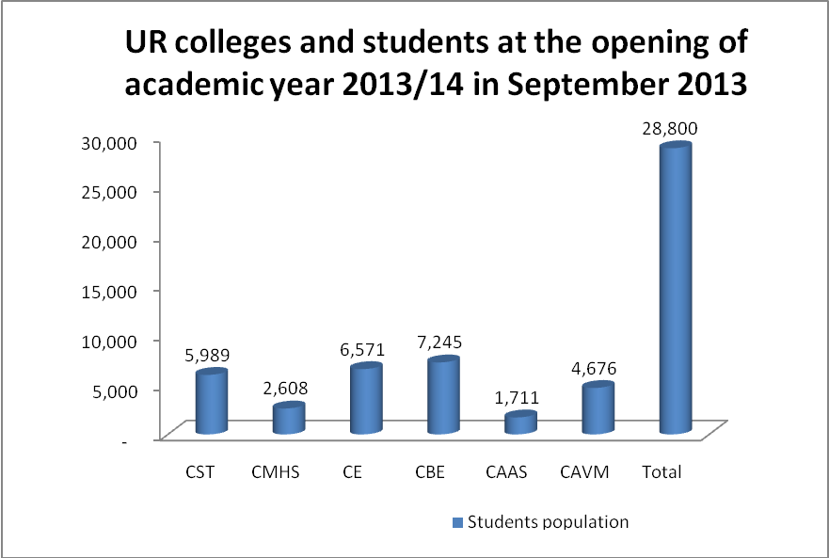
At the time of opening, UR’s colleges employed 2,487 staff. Of these, 1,481 were academic staff, who were predominantly male (79%). The remaining 1,216 non-academic employees were administrative and support staff. Of all UR staff, 87.8% were Rwandese and 12.2% were expatriates.

7.3. ACCESS TO HIGHER EDUCATION
During the reporting period, there were 38 higher education institutions in Rwanda, of which 18 were private and 20 were public. Among the public higher education institutions, 8 were degree-awarding and the remaining 12 award diplomas. The latter category includes colleges of education, colleges of technology, and schools of nursing and midwifery.
In alignment with the stated output goal for the higher education sub-sector, the ESSP 2013/14-2017/18 strategic objective is to increase the number of students enrolled in public higher education from 37,632 in 2012/13 to 39,409 in 2013/14.
During the reporting period, the total number of public higher education students increased from 37,632 to 40,731, exceeding the target. Similarly, the total number of students in private higher education institutions increased significantly, from 38,997 to 43,717 students.
Graph 34: Trend in students' enrolment in public and private tertiary institutions (2009-
2013)
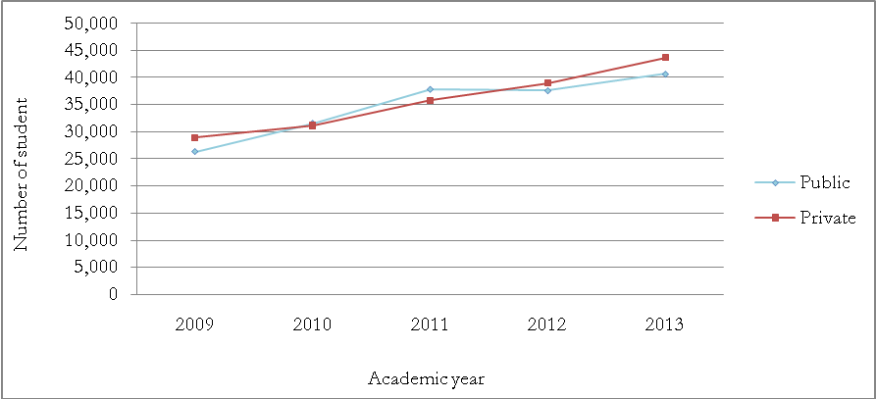
In all types of higher learning institutions, the total number of both female and male students has increased, as highlighted in graph 36 below. The number of male students remains higher than that of female students.
Graph 35: Tertiary education students by sex from 2009-2013
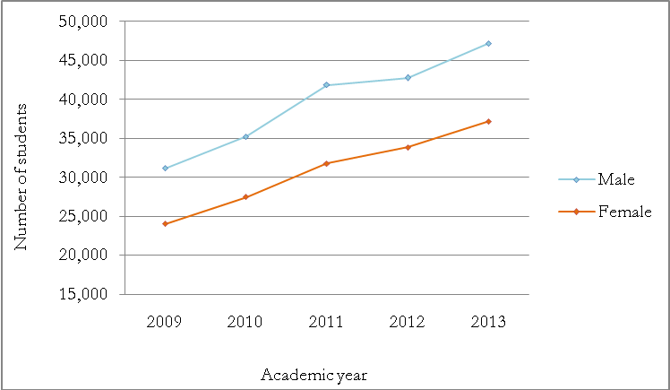
In recognition of the fact that science and technology are essential for Rwanda’s labour market, innovation, and progress in education, ESSP 2013/14-2017/18 strategic objective is to increase the proportion of students enrolled in science and technology fields at tertiary education level from 13% in 2012/13 to 15% in 2013/14. The following graph highlights the share of students enrolled in science and technology-related fields including engineering, manufacturing and construction, agriculture, health and welfare. Percentages for the academic year 2013/14 are reported by gender for public and private institutions.
Graph 36: Students registration in science and technology related fields in 2013/14
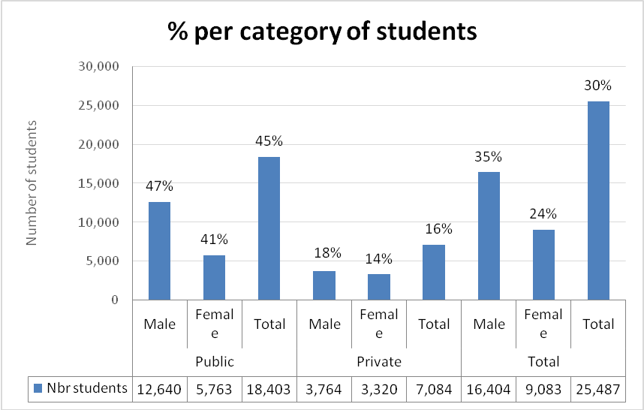

7.4. QUALITY EDUCATION
As part of efforts to supply quality assurance in the provision of higher education, various important activities were conducted by the Higher Education Council (HEC). A summary of these activities is presented in table hereunder:
Table 13: Major activities and achievements in quality assurance in higher education
No | Activities | Achievements
1 | Reviewing applications | - University of Kigali was granted authorization to operate  - Ngoma Adventist College of Health and Sciences (NACHS) was granted authorization to operate  - PIASS was granted authorization to open up a new campus at Rubengera
2 | Conducting institutional audits | Eight Institutional Audits were conducted at IPB, INES, INATEK, INILAK, ISPG, CUR, KP, ILPD
3 | Conducting investigative audits | Two investigative audits of unaccredited programs offered by CUR and INES were conducted
4 | Workshops conducted | In the framework of upholding quality assurance, different workshops / training sessions were conducted, in which around 380 staff (academic and non-academic) from HLIs attended
5 | Assurance that all HLIs fulfill the Student Admission Criteria standards in the academic year 2013-2014 | A verification exercise was carried out in all HLIs to verify the compliance of students’ admissions to the required minimum entry standards in 2013/14 academic year.
6 | Establishment of the University of Rwanda | A feasibility study of UR Infrastructure Development project was conducted, and the draft report prepared. In the same spirit, a procurement plan for UR infrastructure development project was prepared and submitted to Exim Bank of Korea for consideration
7 | Issuing equivalence certificates | 1881 equivalence certificates have been issued at various levels of the Rwanda National Qualifications Framework for higher education

7.5. OTHER ACHIEVEMENTS
Apart from attending to the core business of teaching, Higher Learning Institutions recorded a good number of achievements, summarised below.
- Graduations
Over the reporting period, public higher learning institutions graduated a total of 9,711 students in various fields, of which 6,390 were male and 3,321 were female. The private higher learning institutions graduated a total of 6,990 students in various fields, of which 3,169 were male and 3,821 were female.
- Students support, partnership and community outreach
Particular effort was made by the HLIs to support their students’ and former students’ professionalism, as to prepare them even better for life after the completion of their studies. Such initiatives include the seven training modules in procurement management which have been developed, and are now being delivered, by the College of Business Economics with support from the International Training Centre for the International Labour Organization. The content of trainings was based on the training needs assessment results. The same college initiated weekly talks for students, with participation from entrepreneurs and other guests.
The above is only one example of multiple collaborations and projects undertaken by HLIs. In the period under review, public higher institutions of learning joined into collaboration partnerships with over 100 institutions within and outside Rwanda.
All of the public institutions have also undertaken various community outreach activities related to their areas of specialisation. Examples include the production of topographic maps under the Centre for Geographic Information System (CGIS) of the College of Science and Technology (CST), trainings carried out by different institutions, and various health and medical activities conducted by the College of Medicine and Health Sciences.
- Research development, publication and consultancy
Over the reporting period, Higher Learning Institutions carried out various research activities, publications and consultancies in different thematic areas responding to Rwanda’s needs, in line with EDPRS2.
In this regards, the Ministry of Education is proud to report that over 200 publications were recorded, further 16 submitted for publication in local and international scientific journals, 7 book chapters published, and several papers presented in international conferences.
In line with the goal of increasing income-generating activities, higher learning institutions have undertaken various consultancy works. These generated nearly 204 million Rwandan francs.
- Infrastructure development
Over the reporting period, the main achievements recorded in infrastructure development were the construction of a three-storied digital library and lecturers’ offices block, one girl’s hostel, and a multipurpose hall at Rukara College of Education. Furthermore, a modern library was nearly completely constructed in the College of Science and Technology. A laboratory for Malaria Entomology was also constructed in the school of public health. This was done in partnership with the Ministry of Health/ Rwanda Biomedical Centre Malaria Division.
- Staff development
A significant number of HLIs’ staff enrolled in further studies. In 2013/14, 112 HLIs' staff were recorded in PhD programmes and 59 in Masters programmes.
- Others
During the fiscal year 2013-2014, Government support of education development in private higher institutions of learning was monitored. This assessment concerned, among others: Institut Polytechnique de Byumba (IPB), Institut d’Enseignement Supérieur de Ruhengeri (INES), Institute of Agriculture, Education and Technology of Kibungo (INATEK), and Nile Source Polytechnic of Applied Arts (NSPA). The findings showed that private HLIs which received support from Government did indeed utilise it for education purposes.
In addition, critical thinking and values have been promoted and emphasised during the last fiscal year. Civic education has been strengthened through the two programmes locally known as “NdiUmunyarwanda Program” and Itorero. The two programmes are aimed at fostering community spirit and common values among Rwandans, to boost the country’s socio-economic development.

7.6. CHALLENGES
During the reporting period, institutions of higher learning recorded a number of challenges, the major ones being the following:
- Not enough laboratory technicians to operate the laboratories in the University of Rwanda;
- Low number of academics and researchers applying for the research grant;
- High staff turnover;
- High reliance on expatriate staff in certain areas.

7.7. KEY RECOMMENDATIONS
The above challenges should be tackled with the following actions:
- Training and additional motivation of laboratory technicians to ensure their availability and retention;
- Elaboration and implementation of an aggressive staff development policy;
- Elaboration and implementation of staff retention strategies;
- Tackling of the financial and material issues which hinder the ECD and catch-up programme;
- Increasing the financial and material support for the adult literacy programme.

